THE KIDD FAMILY IN NEW ZEALAND
1859-2009
150 YEARS SINCE THE
ARRIVAL OF
THOMAS AND MARY
KIDD

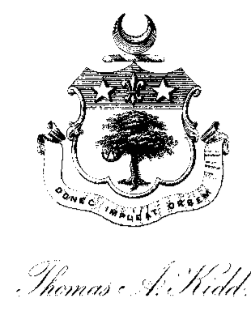
THEIR DESCENDANTS AND ANCESTORS

Kidd Family History.

Commenced January 1997. ( by G.E.Kidd.)

Following my visit to U.K. in 1993 during which I was able to make contact with other Kidd relatives, gather more information, and visit places in Keady and Newry of family significance, I decided to gather and build upon the family history prior to Thomas Alexander Kidd coming to New Zealand in 1859.
.
I had previously been helped by old correspondence, photographs up to 1900, by visits by my father Edward Kidd to London and Ireland while on leave during World War 1 when he was able to make contact with a number of Kidd cousins. There had, been kept some correspondence and photographs from them up until about 1950. My cousin James Hugh Kidd had visited Amy Kidd at Seven Oaks in 1945 at the conclusion of hostilities in Europe. She was a daughter of Leonard Kidd, T.A. Kidd’s brother.

A copy of a family tree given to me by Diana Kidd during her visit to New Zealand in 1994 was of immense value. It was of great regret to hear of her death late in 1994.

I had also been able to obtain a print out of Kidd information from L.D.S records. This helped to confirm names but in some cases I have since found the given dates are not always correct. It became more and more obvious that further research was possible and in all probability would be successful, but would require some time by a professional researcher.

More and more I became interested in another visit to Northern Ireland , provided I had previously gathered enough information. With this in mind I wrote to Armagh Ancestry asking them specifically to research about Thomas Alexander Kidd and his father Hugh Kidd, where they lived and the nature of their occupations. I was initially given photocopies of the report from the Newry Telegram October 14th 1841, giving the details of Hugh Kidd’s death jumping from a rail carriage and also a death notice in the Armagh Guardian May 29th 1863 of his wife Eliza. I then requested Armagh Ancestry to do further research. On the strength of knowing I had further information to work on I visited Northern Ireland again in June- July 1996.

On arrival I visited Armagh picked up material they obtained for me, spoke to Grace Greer, who had done the research, and was given more information as to what was available at the Public Record Office in Belfast. There proved to be an extensive collection of papers relating to the Kidd family available at the Public Records Office.
They were obviously notes and papers made by members of the family over many years and instead of being destroyed had been handed into the Public Records Office. Many of them repeated information but were useful as cross-references. There were also extensive records of leases and wills that I was unable to look at in the limited time available. I spent two and half days there but time seemed to go so quickly.
Perhaps my most surprising find was a copy of the North Auckland Times of Dargaville dated July 13th 1933 that contained the obituary of my grandfather James Kidd. The newspaper had been addressed to Dr Leonard Kidd in Eniskillen. Obviously sent by either my father or one of my aunts. A visit to the Armagh County and District Library in Market Rd Armagh enabled me to obtain photocopies of reports of the inquest into the death of Hugh Kidd and when in Newry I visited the library there to search microfilm of the Newry Telegraph 1857 to see if I could find any report of Thomas Alexander Kidd being presented with three silver salvers when he left Newry. This I was unable to do but I did find extensive reports of an inquiry following accusations by T.A. Kidd against the Poor Law Commissioners.

Of extreme interest was that Grace Greer had a request to do research about exactly the same people for a lady in California. Anne Helms who was the person concerned was descended from Hugh Kidd’s brother George both of whom had married McKinstry sisters. I made contact with Anne Helms and have exchanged information and visits with Anne and her husband. She was a great help with transcribing some of the handwritten notes. Her branch of the family had immigrated to Canada and then made their way to U.S.A.
My final source of information came after a visit to Newcastle to visit Suzanne Conyngham-Greene who is descended from the Reverend Archibald Kidd through his son Dr William Lodge Kidd of Armagh. Her grandmother in conjunction with Col. Graham Kidd, Dr Graham Kidd’s grandfather had collected information in the 1930’s and also compiled the family tree given to me previously by Diana Kidd. As a result of this visit I was able to obtain a copy of these chronological notes which proved to be a great record not only of people but also places. As is the nature of research had I had this record at the beginning I would have been able to see more places of interest in the Keady area. The end result however was a much clearer picture of family who came to Ireland in the early sixteen hundreds to escape the persecution in Scotland of protestant Presbyterians, settling first in Dunluce, where some survived a massacre of Protestants in the 1641 rebellion. From there they moved to Antrim and finally to Armagh and the Keady area, where for the next 200 years until the death of Samuel Kidd in 1850 they were involved in the linen industry.

The more I learn about them the more an interesting picture emerges. I hope to be able to compile a record which is as accurate as possible with the information I have collected. I would hope that branches of the family from the last hundred years can be contacted and their contributions added to this story.

THOMAS ALEXANDER KIDD (1813 – 1869)

Thomas Alexander who came to New Zealand with his family in 1859 and is my great grandfather was the eldest son of Hugh Kidd, he was born in 1813 at “New Holland” Hugh Kidd’s house which is just outside Keady. From an Old French textbook in my possession (Thomas Alexander Kidd, Belfast Academic Institution, 19th September 1826) it was obvious that he received a good education of a kind only the reasonably well to do could afford. Some of the books that he brought to New Zealand and have survived down the years, show he was a very well read man.
He was probably born at New Holland, but it is possible that about this time Hugh Kidd shifted to Armagh. Public Records Office records show Hugh Kidd assigned a lease in Keady in 1812 (D 889/1/103) and made leases in Armagh 1812-1825 (D 476/43,113A,182, 183.) as well as others.

In the early 1830’s (lease to Hugh Kidd Newry 1836 T 577 {66 } ) it appears that Hugh Kidd shifted into business in Newry. T. A. Kidd would by this time be in his early twenties and it is likely he and his next two brothers James and Frederick were part of the family business.

On November 12th 1840 he married Mary Agnes Blanchard in St. Mary’s Chapel in Liverpool, according to the rites of the Catholic Church. His father was listed as a Miller and her father John Blanchard was also listed as a Miller.

After the death of Hugh Kidd in 1841, I presume his business interests were taken over by T.A. Kidd and his brothers, James and Fred William.

Slater’s Directory of 1856 lists Kidd Thomas Alexander Esq. J.P. 81 Hill St Millers. Other Directories list T.A. Kidd as follows, 1854 Newry Magistrate, 1850 County Down 11 Merchants Quay, Newry. Steam Packet Office. 1855 Co Down Kidd Thomas A., Town Commissioner, Newry (not listed 1857). Other entries in Slater’s Directories include: - 1846 Mrs Kidd Needham Place, 10 Mill St. Corn Merchants. 1854 Kidd Bros. Props Newry Mills, Bakery and also in the same year, Kidd Bros., corn meal, flour merchants, millers and bakers Mill St.

From the proceeding it is obvious this branch of the Kidd family was very much involved in business in Newry at least between 1836 and 1857, in which year T.A. Kidd and his brothers left Newry. Reference is made to Kidd Bros. Proprietors of the Newry Mill and Bakery. An Ordinance Survey Memoir 1835 Newry describes the flourmill situated in Mill St as having two water wheels the first twenty feet in diameter and four feet broad, the second eighteen feet in diameter and four feet broad. They were both undershot wheels and the fall of water was nine feet. There was also a steam engine of 16 horsepower attached to the Mill.

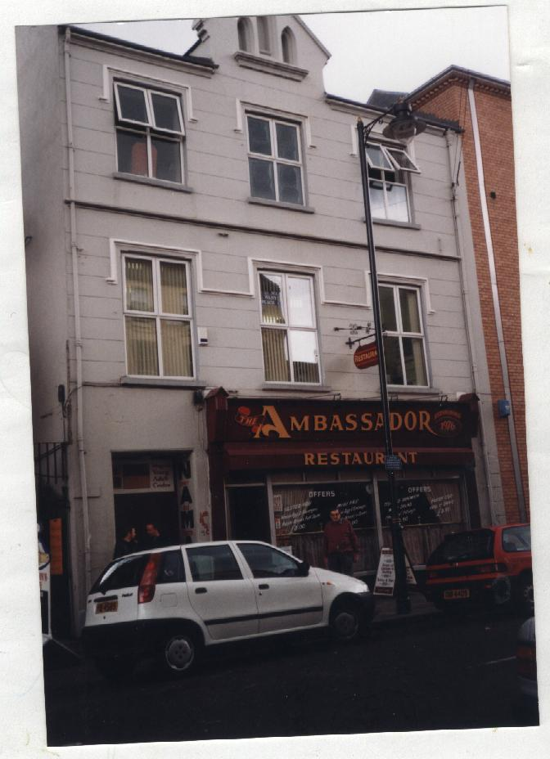
T. A. Kidd’s residence at 81 Hill St can still be seen in Newry, it is alongside the Library which is a relatively new building and takes up three of the old street numbers. 81 Hill St is now a restaurant but can be seen quite clearly in some old photographs which I obtained from the Newry Museum. Prior to 1760 the Hill St area was known as the ‘low ground’. It was then acquired by Lord Hill (Marquis of Downshire) who laid it out in its present pattern. The streets and squares in the area all derive their names from members of the Hill family. Hill St was once home to the town’s leading citizens. Today it is the main shopping street with a fine range of family owned shops and well known multiple stores. The corner building No 108 is the site of the former Crown Inn where Wolfe Tone formed a branch of the United Irishmen.

Hugh Kidd probably lived in Needham Place as reference as stated previously is made to Mrs Kidd Needham Place and 10 Mill St Corn Merchants. It is now rather hard to find exactly where Needham Place is as the by-pass road appears to pass through the area where Needham Place and the commencement of Mill St were. The first Presbyterian Church that was built in 1853 is supposedly in Needham Place. The building which was T.A. Kidd’s Steam Packet Office 11 Merchants Quay is visible and would have been only a short walking distance from his residence in Hill St.

Political and Religious involvement: -

Although his father Hugh by virtue of his burial in St Marks Church in Armagh was a member of the Church of Ireland, T.A. Kidd’s wife was a Roman Catholic and they were married in a church of this religion. Their son James was christened in the Roman Catholic Dromore Diocese at Newry. It has been suggested that T.A. Kidd was a supporter of the First Presbyterian or the Unitarian Church however this can not be proved. There is however no doubt that he was involved with people from these Churches.

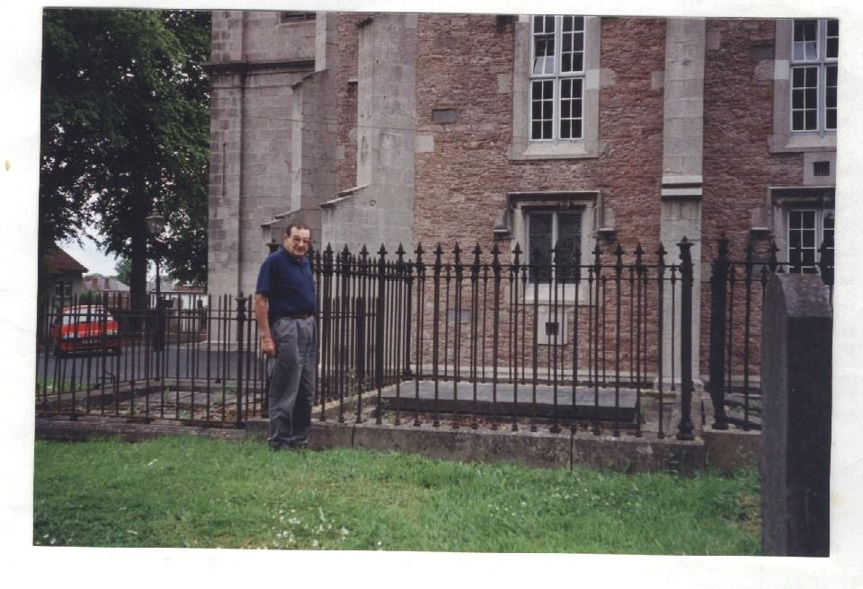
While on the subject of religion it is interesting to note that all the Kidds were connected with The 1st Presbyterian Church (The Temple) at Keady until the 1790s. This church I found was a mile or so outside of Keady, and was originally built there in the early 1600s as they were not allowed to build it within 8 miles of Armagh. The Established Church of Ireland was as much in conflict with the Presbyterian Church as it was with the Catholic Church. There was evidently a big upheaval amongst the various congregations after the formation of The Society of United Irishmen in 1791 and the rebellion of 1798, some moved to The 2nd Presbyterian Church in Keady, notably George, Hugh Kidd’s brother, who was buried there and his brother James who was elected Session Clerk on 14th October 1826. Hugh obviously joined the church of Ireland because of his burial at St Marks others remained with the 1st Church. Some tensions there must have been.

Hugh Kidd’s Grave.

Kidd notes record that Hugh Kidd’s fifteen-year-old daughter Jane, T.A. Kidd’s sister, was killed in a coach accident when arriving at Newry on 13th September 1837. Newry was illuminated for the Queens Coronation but Hugh Kidd’s house was the only one in darkness. This was put down to their political opinions but was really on account of his daughter’s death. He was a liberal like all the Kidd’s at that time.

(Public Records Office Northern Ireland) The Newry Examiner 1831 2nd January records a Reform Meeting in Armagh being held by Hugh Kidd and Henry McKean. 1826 Synod of Ulster: - Leonard Dobbin and Hugh Kidd asked for a rehearing etc. In 1854 2nd January it is recorded that a dinner was given to William Kirk in Newry by Thomas A Kidd and others.

William Kirk like his father, was a Liberal MP for Newry for many years. He was also a Presbyterian Church member. I have in my possession signed etchings of William Kirk and John Mitchell. They used to hang in the former billiard room in our residence and no doubt my grandfather had inherited them from his father Thomas A Kidd.

John Mitchell {1815 –1875} was only two years younger than T.A. Kidd. He was the son of the Presbyterian minister in Newry and is buried in the Unitarian Graveyard behind the Convent in High St Newry. He trained as a lawyer and was the founder of the United Irishman Newspaper, through which his revolutionary call to arms led to the passing of the Treason and Felony Act, under which he was tried and sentenced to fourteen years penal transportation. He later returned a hero and became a Member of Parliament. A statue stands as a memorial in John Mitchell Place Newry.

The evidence points to T.A. Kidd having sympathies with these political views. It is known William Kirk made several attempts as a liberal before he succeeded in displacing the conservative member Major Waring as MP for Newry.

It is of interest that Georgina Kidd in her diary written travelling to New Zealand in 1859 in an entry of October 29th states – “Commenced to read “ Jail Journal” by Mr John Mitchell to day, like it very much so far, gives a capital account of everything”.

Reports in the Newry Telegraph of Thursday 15th January 1857 and Saturday 17th January 1857 give details of an inquiry at the Newry Workhouse into charges preferred by Mr T.A. Kidd by Mr Robinson Poor Law Inspector. They were regarding the valuation and rating of premises in Newry Electoral Division of Newry Union and were against the Union Guardians. There is long and detailed cross-examinations regarding alleged political bias in compiling the rating valuations. In those days of course to be on the roll and vote required rated property.

The Newry Telegraph Thursday 29th March 1857 gives the details of the findings of the Poor Law Commissioners that did not uphold the allegations of Mr T.A. Kidd. The newspaper was very scathing at the conduct of Thomas Alexander Kidd who ventured to allege that “a regular system has been in force, through the instrumentality of the rating and valuations, to affect political interests in the Borough of Newry”. It goes on to give the full details of the findings. It is of interest that at this time or there about Thomas Alexander Kidd and his brothers appear to have left Newry. Thomas Alexander going to Liverpool, James to Sligo, and Frederick William to Dundalk. This would appear to end the Kidd involvement with Newry. It is not clear if their mother Eliza and unmarried sister Eliza, were still living in Newry. They may have shifted to either Keady or Armagh to live. A letter from her son Surgeon Leonard Kidd from Port Elizabeth in 1854 describing being shipwrecked was reportedly written to his mother in Keady. Eliza Kidd widow of Hugh Kidd died at the home of her son George H. Kidd of Gr. Brunswick St. Dublin, on the 24th of May 1863 aged 76 years, their surviving daughter Eliza died on the 25th of May 1895 aged 78 years. They were both buried at St Marks Church Armagh as was Hugh.

Thomas Alexander Kidd left Liverpool on 12th September 1859 for New Zealand accompanied by his wife Mary Agnes five daughters Eliza, Georgina, Mary, Helen, and Fanny, and one son James. James aged 9 at the time was my, Graham Kidd’s grandfather. Thomas Alexander was farewelled by his brothers, James, Frederick William, George and Leonard, also his brother in law John Blanchard, and cousin James Patrick Kidd.

They travelled to New Zealand on the White Star clipper “ Shalimar “ 1402 tons
Thos Alexander and his family were accompanied by James Faughey, who had been in the employment of him and his brothers. They also brought Annabella McCormick daughter of Hugh McCormick of Newry as a servant. Information from Don Bradley a direct descendant of Georgina Kidd [Bradley] now living at Lake Hawea (now deceased 2007), says that Annabella McCormick married a man named Wright, and she founded a firm of A.B. Wright ( using her own initials ) which became a well known carrying company and custom agency. The firm was noted for its teams of white and grey horses. When three sons of the Bradley’s moved to Auckland from Arapohue ( Longwood ) in 1919, their effects were handled by A.B.Wright of Auckland.
Dissatisfaction was expressed at James Faughey by Thos.Alex. early in 1860 and it is suggested that he wanted to go home. Leonard Kidd in a letter 3rd Nov. 1862 says—“I was glad that James Faughey is likely to go back to Enderley for awhile. I hope the sawmill etc may spring up under his hands.” In the letter from Merton Villa, Bootle, dated 22nd Feb. 1865 it is written about the old house at Enderley being burnt down in Nov 1864. The family shifted back to Auckland and I would say never returned to the Taraire Block.

Extracts from Georgina’s diary state the Shalimar passed The Three Kings and North Cape of New Zealand on the evening Friday 16th December, 95th day out “We may be in Auckland to morrow evening or Sunday”.
96th day out Dec.17th. Last Saturday spent on the Shalimar. “The cow and pigs were out and the decks were getting holystoned and washed down”.
“Mr Cameron came to the window this morning at 4 o’clock to say for us to come on the poop and see the sunrise and the coast of New Zealand. So Eliza, Mary, Nelly and I jumped up dressed ourselves anyhow and went up and Mr Cameron was waiting for us although he was off duty at 4am. It was a delightful morning, the air was so fresh and sunrise at sea infinitely more worth seeing than on land. When we came in Eliza dressed properly while Mary, Nelly and I went back to bed”.
They made slow progress down the coast but finally on December 22nd (101st day out) the pilot came on board at 4 pm off Rangitoto Island and brought the ship up off the North Head of Auckland with port anchor and 30 fathoms of chain.
December 23rd. “We were all up early this morning. The ship was moored off Auckland this morning and a good many passengers went ashore. Papa, Mamma, Jimbo and James Faughey went to look for a house”.
December 24^{th.} “We tore down our cabin this morning and packed everything ready for going ashore. Papa and James Faughey went in the boat with the luggage and M r Cameron invited us to dinner in the saloon after which he took us ashore in the “Captain’s Gig”. We were exceedingly sorry at leaving the “Shalimar”. I never had such an idle 3 months in my life and I suppose I never shall again. Our house is a very nice wooden house with five rooms and a very good kitchen and is situated on a hill near the windmill. The town is much better than I expected”.

Extracts T.A. Kidd’s diary:- Engaged Captain Ryles’ house corner of Edwards St. and Abercrombie St. at 21/- a week.
9th March 1860. Had looked at land on the Kaipara River called the Kaukapakapa early in January. Very good land, but means of communication frightened them. A land sale took place in January and sent in applications for 4 lots 21, 22, 23, and 24 in all 370 acres near Kaeo. 21st January proceeded with others in the schooner Kiwi to Whangaroa Harbour where on arrival inspected the land and were all well pleased with the quality and appearance of the whole Taraire Block.
He must have stayed there until near the middle or end of February and then travelled to the Kerikeri entrance via the Bay of Islands where he embarked on the St Kilde and then to Auckland arriving on Thursday afternoon the 1st of March.
He found when he arrived that his wife Mary who had been dangerously ill for a week or 10 days, had on the previous Monday night given birth to a son who only lived 3 days. To quote:- “ I was shocked to hear that Mary had been so ill. Thank God she is now in a fair way of being alright. She sat up a short time to day for the first time. She was attended by Dr Neill assistant surgeon of the 65th Regiment who has been most attentive and with whom she is most pleased”
Further details are given of house plans and advice of crops to grow and grass seed mixtures to sow
What actually happened to the family when they shifted back to Auckland is uncertain. It has been told that son James attended the Church of England Grammar School. Like many others he went to the Thames Goldfields with little success. It is also known that he was in the Poverty Bay when Te Kooti was raiding and was a member of the garrison called out to defend Gisborne. He was issued with an army musket which was at the Tatarariki Homestead for many years and has now been fully restored and is to be displayed in the Dargaville Museum. James was now 18 years old and probably came back to Auckland when his father Thomas Alexander died on the 4th July 1869 at the age of 56. James was employed by R Baird & Co (1869, for nine months) and also by the Auckland Provincial Council during the session of 1870-1871 as a messenger. About this time he shifted north to Arapohue where his sisters Georgina and Fanny were living.

Franklin Bradley (2nd February 1831-3rd May 1909) was a Non-Subscribing Presbyterian minister in Northern Ireland and England and the first minister to Unitarians in Auckland. Bradley had heard of another Unitarian Thomas Alexander Kidd who sent back favourable reports about their new country. (see more about Franklin Bradley in the appendix). The Bradley Family except for one brother all decided to go to New Zealand which they did in 1863. Franklin at some period travelled to the Bay of Islands (Kaeo probably ) where he fell in love with Georgina Kidd who eloped with him in 1865.
In 1865 the Bradley Family finally moved to their land in Arapohue. Life was hard breaking in the land and building permanent houses. They lived in a nikau whare for a start. Franklin and Georgina’s house Enderley was not completed until 1873. Georgina had originally been banished from her family but all was forgiven when her sister Fanny marred Samuel Bradley in 1870. Franklin and Georgina had seven sons and two daughters.

Eliza Kidd 1841- 1938 or 39, the first born child of Thomas and Mary Kidd , was the last to die in her late nineties. She married Dr Alexander (Sandy) Young but as far as I know was only married for about twelve years before he died. Her first occupation in New Zealand was as Governess for the daughters of John Logan Campbell. She later taught at Lower Glenside School for Girls in Beckham Place Grafton near where the Motorway is now. She took this school over on the death of the previous Principal Mrs Glover in 1888.
Glenside School and the one in Beckham Place may have been different. An article in the “Herald” in 1937 on the eve of her 96th birthday gives her impressions of early Auckland and that at one period because of her mothers failing health she gave up teaching and went to Devonport to live but her mother fretted to get back to town to be near a doctor. When they did she opened a school for girls in Beckham Place Grafton which is across the gully from Glenside Crescent. At the school she had boarders. My aunt Edna Kidd attended her school.
As her mother lived with her for many years, Eliza had many of the original Kidd bits and pieces in her possession and these where handed down to my Aunt Edna Kidd.

Georgina Kidd 1843-1922 as mentioned above married Franklin Bradley on the 7th July 1865. She had seven sons and two daughters, neither of whom married. The Bradleys farmed in the Mititai, Arapohue area then some of the boys shifted to the Ruawai Flats and later to the Tamaki area near Auckland. In a letter to her brother Jim in July 1867 Georgina speaks about life at Arapohue, the view from the mountains, a bull that had disappeared into the bush and hadn’t been seen for ages and that the house was not finished as they had run out of timber. As the sawyer had gone Sam and Mr Beasley are cutting out the rest. Life must indeed been hard for a well educated 23 year old as she was then.

Mary Kidd married Henry Thomas Beasley and had two daughters Mary Francis who married James Curnow and Julia Gertrude who married Charles Sills.

Helen Kidd (Nellie) 1846-1919 married Frederick Eric Thompson 1844-1914 in 1873. He was a boat builder and built kauri row boats for the Antarctic expeditions. They had two children, Charles and Mary Wilhelmina (Mina) 1874-1958 who married John Frederick Smith 1868-1955 in 1891. They had three sons and three daughters.
Mina built and owned The Grand Hotel in Taumarunui for many years. Her husband moved to Western Australia in 1911 with the eldest son where he was involved in the timber milling trade. Mina and her daughters and remaining sons moved to Western Australia in 1915 but she later returned to Taumarunui with her daughters leaving the sons with their father. The boys all became successful timber millers or farmers in the West.
One of the daughters Aileen Lenora married Cyril Mitchell a successful architect whose daughter Jean married Brian Carter who contacted me a few years ago. He had met Roger by chance on the “Bounty” on Sydney Harbour in 1993. Unfortunately I later lost contact with him.

Fanny Kidd 1848-1929 married Samuel Bradley 1842-1911 at his sister Mary and her husband Richard Masefield’s house in 1870. They lived near Franklin and Georgina, they called their house “Longwood”. They had four sons and three daughters.

James Kidd 1851-1933 was born in Newry, Co Down and married Ann Jane (Annie) Bassett 1854-1944 on May 3rd 1882 in Auckland. She was born in Portaferry Co Down Ireland..
James Kidd lived farmed and contracted at Pah Hill before purchasing a piece of land at Tatarariki near his Bassett brothers in law in about 1891. He built a house on the property and shifted there with his family in 1893. He called the house “Clanrye” after the river that runs through Newry. Edward was the only one of his children born at Tatarariki in 1894. My Aunt Edna was about five when they shifted and she told me the front paddock near where the Hall is now, was full of stumps and rushes with lots of rabbits.
Most of the farm was very wet and more than half covered with bush and the first job was to dig some drains. The house was built on the highest and driest place and the story is told that my grandfather James Kidd would walk out from the house and stand amongst the flax and raupo, jump up and down and as far as the eye could see the tops would shake, he would then sit down and cry.
With the help of his two elder sons Tom and Hugh he drained, fenced and cleared enough land to milk some cows and when the Dairy Company opened in 1902 he was among the first suppliers. The first cowshed was steam driven with the boiler being fired by wood chopped and sawed from the farm bush.
In the early days on the farm he continued to do contract work on road forming and was the first to open up the Green Hill metal quarry.
He later purchased another piece of land referred to as 97 after the section number. This was eventually taken over by his eldest son Tom... On his death in 1933 the home block was taken over by his sons Hugh and Edward (Ted).

Notes from some cousins—

Kathleen and D’Arcy remember Aunt Eliza sitting in a chair, lace hat and black dress with long sleeves. She taught Kathleen embroidery and how to finish off correctly.
Kathleen said her mother (Auntie Mary) could remember Georgina, everybody seemed to like her.

The descendants of Thomas and Mary Kidd are now very numerous and spread far and wide. I would hope that this record which is by no means as complete as it could be, will be an inspiration to someone to expand and bring up to date.
As can be seen it was begun in 1997 and perhaps would never have progressed this far
without the spur of the 150 year celebrations.

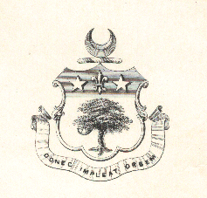
DONEC IMPLEAT ORBEM
Until it fill the World

In the Beginning :- Kidd Family History.

There are several possible explanations for the origin of the surname Kidd. In the first instance it may be of nickname origin, being one of those words derived from some personal or physical characteristic of the original bearer. The source of the name can be traced to the Old English word “cydd” which was used to denote a person of playful disposition.
The name is more probably a diminutive of Christopher. Kit is a pet name of the personal name Christopher which is of Greek origin and signifies “Christ bearing”. Thus the surname simply denotes the son of Christopher.
The name has been recorded in Scottish and English documents since the 12th Century. About 1180 one Gilchrist Kide was registered as holding land near the river Nethan, Scotland, while Ralph Kide of Northumberland is registered in the Pipe Rolls of 1181.

The surname was established in Ireland circa 1586 when English and Scottish Planters settled in parts Leinster under terms of a colonisation policy being enforced by the English Government of the period. Later plantations introduced this name to Ulster where it has been numerous since the Seventeenth Century.

There is no doubt that our branches of the Kidd Family can be traced back to families of that name who lived in Scotland. However in an article “The Kidds in Canada Remote Origins” (Appendix 1) it is suggested the name is of Scandinavian origin.

About or prior to 1630 Walter Kyd of Irvine, a Burgess, Aryeshire with several others migrated to Ireland and settled in Dunluce.
A few miles from Irvine the old families of the Kyds of Craigie and Woodhall resided so there is hardly any doubt that the Irish Kyds are their descendants. Kid of Craigie was a younger son of Woodhall.
There are recorded extracts from the Privy Council and Register of Scotland 1585.
Scottish state papers vol 3, p742 which make reference to a number of Kids or Kydes
1583 3rd Feb.
Soldiers complain of John Livingstone, amongst others Thomas Kyde.
1569
Robert Kid was a Baille of Dundee.
1575
Alex Kid and others were bailed, Mr Pat Lindsey, Minister and Provost of Dundee and others. Cautions for Thomas Kyd and James Kyd his brother not to touch Henry Ruthie of Dysart or his tenants---- Henry and William Kyd witness to bail.
1599
Alex Kid and others bound not to harm J Guild and Sir John Lindsay.

Walter Kyd of Irvine, a burgess, Aryshire with several others migrated early in the 17th century to Ireland. Some members of his family were buried in Dunluce Churchyard, Giant’s Causeway under a stone dated 1630.
This stone is about six feet long and three feet broad and lies flat on the ground near the S.E. wall of the Church and is composed of freestone. The end of the stone next to the road is nearly in line with the gable of the Church, distant about twenty three feet and lies parallel to the side of and between two pairs of standing stones. Miss Helen Kidd ( daughter of George Kidd of Belfast ) had the stone carefully re cut and cleaned up. ( quote dated 1902 ).

The inscription on the stone reads from the top right- “ Heir Lyeth The Children Of Walter Kid Marchant In Dunluce Burges Of Irvin He Made This Stone The 12 Of March In Anno Domini 1630”. The initials in the centre, W K and I M K are supposedly of his children , Walter and Isabella Margaret.

There is no doubt that Walter Kyd resided at Dunluce and the stone as by its inscription was erected by Walter Kyd in memory of his children.
It is sometimes suggested Walter Kyd’s headstone is in the Dunluce Church Graveyard, but this is not correct as recent information gives the names of the dead children and his placeof death.
,
An extract from “Daltherda or North Antrim” by W Davies states:-
1641 (the date is probably wrong)
“There was at this time living in Dunluce a merchant named James Kidd son of Walter Kyd a Scotsman, whose headstone can be seen in Dunluce graveyard, at the present time.
This W Kyd being a Protestant his door was of course marked.
Kid and his eldest son had a suspicion that something was going to happen, and rose long before daylight and were sitting by the fire, when they heard voices and many footsteps. They called the rest of the family to get up and escape when the door was broken open by a band of armed men, and a terrible slaughter commenced. Kid and his son escaped by the back door, but the rest of the family including the mother were all killed.
Kid and his son escaped to a little port below the castle, where they kept a boat which they launched. They saw a small vessel coming from the west into which they got, and were carried to the port of Irvine in Scotland. They stayed there only a short time until they knew of the landing of Munroe in Carrickfergus, and the rebel Army was drawn away from Dunluce. It is not mentioned how many more Protestants were murdered, but (Manus ? ) Roe O Kane’s men set fire to the town after they had cleared it of Protestants Mr Kid came back to Dunluce and found it all in ruins, only the Castle had not been touched. They went to their own house and found the charred remains of their family lying as they were killed. A pot hanging on the fireplace had not been disturbed, but the furniture was all destroyed. The principal families in Dunluce at this time were the Boyces (maybe Boyd ), the Kids, and McKelips, all Protestants.”

Dunluce was destroyed, the outline of the foundations of some streets of houses are visible in the different colours in the grass fields. It would appear that then or soon after the family moved to the Parish of Killylea on the borders of Lough Neagh in County Antrim, and then at the end of the 17th or beginning of the18th centuries moved into the County of Armagh where they located themselves at Keady and mainly occupied themselves with the linen industry, bleaching etc up to the death of Samuel Kidd at Dundrum about 1850.

.
From Dunluce to Keady.

One of Walter Kidd’s sons Benjamin moved from Bushmills probably firstly near Lough Neagh in 1641 (check previous page 1641 may have been his date of birth) and then to a place named Knockraven and Ravenhill in the neighbourhood of Keady, County Armagh. He had six sons, one of whom lived at Old Tassagh called John of Ravenhill, he was born in 1670 and died in 1730 aged 60.
His son Benjamin of Racarbery, Derrynoose and Millmount Keady was born in 1711 died 1758 aged 47. The will of Benjamin Kidd of Racarbery in the Parish of Derrynoose is in the Public Record Office Dublin. The will is dated 25th December 1758 and proved 20th February 1759.
There is a stone erected in Old Tassagh by Benjamin Kidd of Armagh in 1822 to their memory i.e. the above John and Benjamin, with the inscription “ Long dead but not forgotten”, the stone is laid flat.
Benjamin Kidd of Armagh who erected the stone was the 4th son of Benjamin Kidd born 1745 died 1823. He was buried in the Presbyterian Church vault in Keady.
Graham Kidd Te Kopuru, his wife Mary and Mary’s cousin Peggy Jones visited the Old Tassagh Cemetery in 1993. We had to borrow a ladder to get over the stonewall but couldn’t find much as the grass was too long.

Benjamin Kidd 1711-1758
He was married twice first to a Miss Young, they had one son John, his second wife Jane Abbott was mother to our whole connection. She had five sons and one daughter.
These sons, including John by his first wife were often spoken of as 36 feet of Kidds six men 6 feet high. They were John, Samuel, James, Benjamin, William, and Archibald.
The third son James was our great grandfather.
(This quote “our” is in regard to the children of Thomas Alexander Kidd who came to New Zealand in 1859).

The Children of Benjamin Kidd.:-

John 1737- 1808
Lived at Knockraven between Temple and Madden.
Married a Miss Dunwordy
He was left with his brother Samuel the Crewley farm, Knockraven. Mortgaged or sold his share to John Thomas Simpson and Thomas Dobbin. Sold his farm to his stepbrother (half brother) James Kidd in 1807 witnessed by his son John and nephew Hugh Kidd.

Samuel of Linenhaven, 1741 – 1809
Married Anne Kells and had 3 sons Samuel of Dundrum, Thomas of Knockraven and John killed by a gun accident, also 2 daughters Anne and Jane a Mrs Windrum and a Mrs McKenzie. Samuel lived at Isky Meadow and Darkley

Jane born 1743
Married J. Haddon had one daughter.

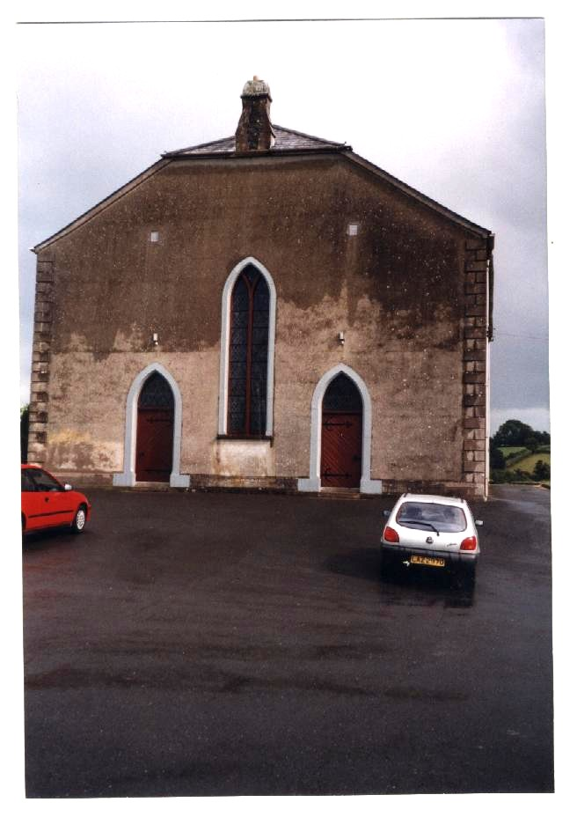
James of Millmount and Tullyglush, Parish of Keady. 1744-1815
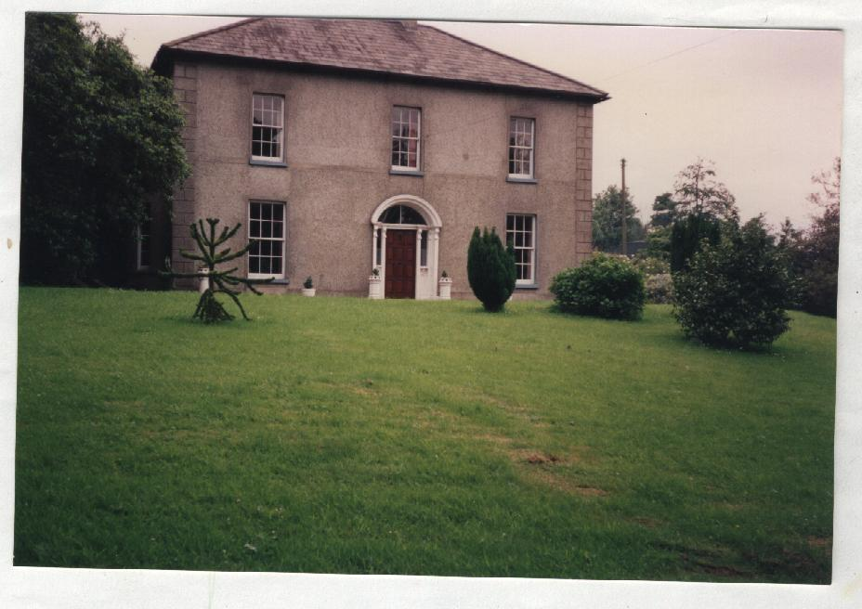
He was listed as a Linen Draper, married Jane Cumming (Cuming not sure of the spelling as it varies between both) in 1775, she died on the 24/7/1822.
James lived at Millmount which is a fine Georgian House and is still in fine condition (see photo). He was involved in the linen industry and it is likely he built Millmount.

Left The Temple, right Millmount.

He was a member of the First Presbyterian Church ( The Temple ) near Keady. He died on the 11th June 1815 (see gravestone
inscriptions)

Benjamin 1745-1823 Captain of Yeomanry, married Agnes Osborne
Had 5 sons--- Thomas, Benjamin, Osborne, Abraham, and Joseph. Joseph father of Thomas Osborne who lived at Armagh and Keady. Joseph born in 1831 was killed in the Crimea, there is a memorial in the Church of Ireland Cathedral in Armagh.

William (Big William) 1748-1814
Married Elizabeth Boyd and had 4 sons and 3 daughters, Mary, Robert, Henry, Boyd, Isaac, Jane and Sarah. He lived at the Bridge Keady.

Archibald M.A. Glasgow 1754-1833
Known as the Rev Archy Kidd or the Lame Preacher (lamed by a sword 1798) Rector of Jonesborough, lived at Madden and Jonesborough, married Bridget Arbuthnot (1783). Suzanne Conyngham-Greene is descended from him.
He had 2 sons and 1 daughter. Dr William Lodge Kidd of Armagh, Richard Augustus Kidd of Wexford and Elizabeth who became Mrs Prentice had a large family and died young.

The Children of James Kidd:-

George of Greenmount 1777-1822
(Anne Helms branch) Married Margaret McKinstry, father of James Alexander Kidd

Agnes 1779

James of Millmount (Jnr) married Eleanor Robinson ( died aged 32 ) children on Family Tree (father of James Patrick Kidd)

Hugh of Armagh 1783-1841 Married Eliza McKinstry. Father of Thomas Alexander Kidd who came to New Zealand in 1859. Newspaper reports at the time record the death of Hugh Kidd on 11th October 1841, when he fell between the train and the platform at Dunmurry Station near Belfast.

Samuel Cumming 1774? America (not mentioned on list from T.A.Kidd but on the Family Tree and on the will of James Kidd.) “Be tender and loving to son Samuel if he ever returns is my desire to you all dear children” 29th Dec.1813.
He is mentioned in Kidd Family Papers, 1815-1887 (Indiana Historical Society) and of sons coming back to sell property in Ireland after his death.

Kidds at Keady

The various descendants of Benjamin Kidd born in 1711 notably his six sons lived in the Keady Armagh area involved in farming, probably linen flax growing. James Kidd from whom our line is descended lived at Millmount which is still in fine condition (see picture).The flax was milled and bleached in this area as is shown in various notes and records in the Public Records Office of Northern Ireland. One was in the Army and another a Minister in the Church.
As time went on they and their descendants spread their interests into business in Armagh and later Newry as corn and flour millers, grocers and shipping agents. In the early eighteen hundreds others started a long Kidd tradition of being Doctors of Medicine. Around this time also, records from the Armagh Library show a lot of involvement in the Church of Ireland as wardens etc. Others of course were still very much involved with The First Presbyterian Church (The Temple) where James Kidd (1744-1815) was buried. The Society of United Irishmen as mentioned earlier was formed in 1791.At first it aimed at redress of grievances under which all classes suffer, culminating in the rebellion of 1798. Many congregations were deeply divided and about this time some of the Kidds went to other Churches, however Samuel Kidd was listed as an Elder of The Temple in 1801 and Benjamin Kidd in 1826.
An 1816 Linen Report said that among the principal buyers at Armagh were George Kidd of Tullyglish and James Kidd of Millmount (Newry Magazine vol 3)

Notes made by Colonel Graham Kidd of Camberly on a tour of the Keady area in 1902.
“Knockraven” now a ruin, used to be called the “Castle” as old settlers had to build houses of a certain size an have a quantity of arms.
William Kidd’s house in Keady near the bridge was burned by the Welsh Horse, for harbouring Dr Steele Dickson.
Lord Blarney had another company and burned houses. See books “Hearts of Steel.”
General Munroe was executed at Belfast as a rebel.
“Tullyglish” built at the same time as Greenmount, for Hugh Kidd on the same plan. Both houses were thatched instead of having proper roofs on account of expense of materials owing to the war in America. Tullyglish is now very dilapidated.
“Greenmount” is very pretty and well cared for with good garden and grounds.
“The Glen” Keady the home of the McKinstry’s is next to the new Masonic Hotel.
“New Holland” Keady owned by Hugh Kidd with 150 acres is a largish rambling white washed house or cottage just outside Keady. Hugh used to “bleach” here and afterwards did “fine business” in Newry. The ground was often used as a Park for cricket and football matches. My father Leonard Kidd (Col. Graham Kidd) and Uncles and Aunts born there. As stated earlier the Kidd involvement with Keady ended with the death of Samuel at Dundrum in1860.
It was reportedly said “The Kidds have left Keady and may the devil go with them”

Hugh Kidd 1783-1841 married Eliza McKinstry 1786-1863 in May 1809 and had twelve children, six sons and six daughters. Three of the girls died within a year or eighteen months, one at the age of nine and another was killed in a carriage accident at the age of fifteen. Eliza who never married, died at the age of 78 in May 1895.
Of the six sons five survived to adulthood. Thomas Alexander as detailed previously came to New Zealand. Hugh’s next sons James and Fredrick William were involved with Thomas in business in Newry. George Hugh became a very prominent doctor, (see report of his death in the “Irish Times” 31st December 1895). Leonard the youngest was also a doctor and became a Surgeon General in the Army.
Fred W. Kidd was father to Hugh, Charles, Fred and Dr Leonard Kidd of Enniskillen. Charles was father of Dot Temple an actress and Kathleen, while Leonard was father of Rita. My father Edward met the three girls in London during World War I.
They were evidently a very close family as can be seen by them all being present to farewell T.A. Kidd when he left for New Zealand and the continuing correspondence afterwards.

Appendix Notes:-

1:- This article ‘The Kidds in Canada Remote Origins “ shows that they are descended from Walter Kidd the same as we are. It gives more information about the origin of the name Kidd and additional details of their activities at Dunluce.

The Kidds in Canada I:Remote Origins

The name Kidd is essentially Scottish. Most authorities suggest its origin as a transdisposition from the Scandinavian KID, meaning water-carrier (and one has only to look up Kidd in the Copenhagen telephone directory to see the name is common enough in Denmark!). Another origin is that it was a celtic name recorded in Anglo-Saxon times in Wessex (West England, Wales), as Cydd, a family name from the place Cyddesige in Wessex. This is recorded in the 5th and 6thcenturies, sometimes appears as Ceada, Ceadda or Cyddi, with the entitling – Ceada-wallon. This was anglicized by early historians to Cadwallon - hence in 630 A.D. Cadwallon was a leading West Saxon, of the line of the kings of Wessex which abdicated in 688 A.D. The name is Ceada, and the 'wallo' or 'wallon' is the place suffix. Incidentally, the famous man who burnt the cakes was Alfred Cead of Wallon, King of Wessex! In the Domesday Book (1066) and all that, we find under 'Landowners and Householders' A. Cedde, G. Cedd, A. Cydd, and under 'Chief Tenants', G. Cedd and Cedde, S.
However, the chief load of Kidds has always been Scottish of clear-cut Scandinavian origin, suggesting our fore-bearers were Norse and Danish sea-raiders who settled in the north-east of Scotland during the 8th and 9th centuries A.D. This is universally accepted by Scottish Kidds whom I have spoken to, and also by most written authorities.
In the 12th century the name Kidd is recorded in Angus. the coastal county in the North East of Scotland. Besides this blunt fact of name record, we have the information in 'The Scots Peerage' that 'Sir Patric Gray of Broonouth hath charter from King Robert 11 of Scots of the few of all that part of lands of Langforgund in the Baronie of Craigie which belonged to Christina Kidd, daughter and heir of deceased Sir Roger Cissons. to him and his wife and their heirs, dated in Perth 16th January, 1377.' Interestingly, Craigie is about 40 miles from where I am sitting at the moment!
Another little snippet emerges in the memoirs of Lord Strathallon; "In anne dom. 1668 upon Friddai the 28 febb about 12 of ye clok in ye nighte I, ye lorde Strathalloune was marrit in ye abbie Churche of Holyrud palace by mr. James Kid actual minystere ther.'
The Kidds appear from time to time, but always in Craigie, or other adjacent parts of Scotland. In Burke's History of Arms; 'James Kide, b. 1598 was Lord of Craigie in Forfar and he died in year 1681. He left one son, Robt. of Craigie and James who died in-fant. Wm. son of Robt. Kid of Craigie married the Lady Bessie of Sir George Paterson from the county of Argyle'. There are Kidds in Craigie yet.
The direct line for us starts about 1550 in Irvine in Ayrshire on the other side of Scotland, when Jonne Kid was born. How he got there we don't know but we know for sure that there were no Kidds there in 1500. Jonne Kidd was Laird of Corsfurd, near Irvine. Items concerning this were recorded in the town annals in 1601, 1607, 1608 by 'Johne Neilsoune, ye treasurer.' His son was Walter Kid, my 13th great-grandfather. His connection with, and settling in Ireland was evoked by trade and this is seen in the following reports:
'1620: Irwyn iss a smalle burgh towne lying at the mouth of a rivier of ye same name which hath summetyme been prettie small port but at present chowked up wi sandes which westyrn see beates into it, so as it wrestles for lyfe to maintyne a malle trade to Franse Norway and Irelande'
'1565-1603: Hayes McCoy records this as a great period of trade between the 'near Scottish ports and the ports of North Irelande that are Glynarme, Rade Baye, Dunluce, Banmouthe, SuJlie and Foil (Glenarm, Cushendall, Dunluce, Colleraine, Lough Swilly and Derry-Iough Foyle in modern times)'.
Walter Kidd, Johne Kidd of Corsfurd's younger son, was owner of a trading vessel called 'The Rigge'. He must have traded especially with Dunluce, for it is there that he settled with his wife and family, thereby starting the Kidds of Ulster. Why he settled there was clearly politics and finance. Sorley Boy MacDonnell of the Glens (Gaelic Somhairle Buidhe mac Domhnuill) was a wealthy and recalcitrant Irish chieftain who occupied Dunluce in 1558, displacing the Norman-Irish MacQuillan clan, and holding this formidable fortress against the English. The Irish King, Shane, Chief of the O'Neills, was at this time making distinct trouble for Queen Elizabeth and the Earl of Essex. Dunluce was a key point, and a key port. The Mac Donnels sought Scottish aid for their endeavours, and needed ships to bring the mercenaries. known as "gallowglasses' from Scotland. They got these ships from the Scottish merchant traders, of whom Walter Kidd was one. The mercenaries were highlanders, described by Sir Arthur Chichester (whom one fine day they assassinated)as 'a very savage and heathenish people, speaking Irish, wavering and uncertain, better affected to this nation than to us, liking their manners and dissolute living better than our justice and living under law...'
Such was the enterprise of Walter Kidd. His price was lands, and these he got very close to Dunluce on the borders of County Derry and County Antrim---ownership of the parishes of Ballynaclogh, Ballydivittie and Ballysorreel in the barony of Dunluce. The family held these lands for generations, but not without cost. In the early days they lived precariously with the Irish against the British. Then the plantation started in 1641, and the tide turned, but before that, in 1630, the MacDonnells had turned less pleasant for they raided out their Scottish supporters. On this occasion 2 of Walter Kidds 4 children were massacred, young Walter and Isabella Margaret; the 3rd, Hugh, escaped until things quieted down, and Walter himself returned to Irvine. At Dunluce Castle you can this day see the grave of the young people, with the family coat of arms on it and the inscription 'Heir Lyeth the children of Walter Kid Marchant in Dunluce of Irvine He made this Stane the 12th March in anno Domn 1630' and the initials of the children, 'I.M.K. and W.K.' My grandfather showed me this stone in the derelict graveyard south of the castle bastion when I was a child and told me then that Walter Kidd was his 11 th great-grand-father.
Hugh Kidd was very smart. He married the daughter of Captain Stewart who was enforcing the plantation in his area and thus became a planter himself, fully retaining his father's prize for bringing troops against the English! His son William continued on after his death. Old Walter died in Irvine in 1665, on which occasion the sale of his ship is recorded. William's eldest son was Francis, who retained Ballynaclogh, now called Ballyclogh, from the Earl of Antrim in 1718, but sold Ballydivittie and Bally Sorreel to the Stewart family (related by marriage) in 1729. I don't know when Francis Kidd died, but his son Hugh became an absentee landlord from Ballyclogh and moved into County Derry where in 1756 he seems to have become involved in some speculative real estate; "Item, Hugh Kidd and late Francis Kidd, gentlemanne and esquire of Ballyclogh in Baronie of Dunluce particuer rent rolls here of houses tenements and holdinges by water side Colrayne in County of Londonderry ye yeare of grace 1756". The family must have been interested in this area for some time for as early as 1669' Jonne Kidd, Waiter's youngest son, was paying hearth money tax for the parish of Ballyeghran in the County of Derry.
From this point in time down through the ages it has been very easy to keep check on the locality and vicissitudes of the family. This is largely due to the frequent rebellions, wars and uprisings, which conveniently provides records of conscription and inventories as to which houses held which amounts of arms. As well as this, the Ulster Scots never intermarried with the Catholic Irish or with the English, thus a discrete continuity has always been maintained. From the early 18th century on, the details of the family are more and more comprehensive and I cannot do justice to them in this memorandum. However, to make the story clearer, I have included a few historical maps which indicate the areas planted and the course these people have taken. Kidds have always remained about North Antrim and East Derry, letting the original lands to younger sons of the family while the mainline tended to move southwards through the route of County Antrim. 150 years ago we were in 3 distinct branches; my own, always remaining in County Antrim (came from Ballyclogh to Ballinderry in 1728, settling in the house there about 1746 - Kidd's Loan is there for all to see, thence in my great grandfather's day to Lisburn, and my father to the city of Belfast), the Armagh branch (who really thrived both in society with a capital S, and in finance with linen), and your branch from East Derry. So our relationship is a way back one, our common ancestor lived in the 18th century!
A "knowledge of our ancient roots has also been gained through a letter written in April, 1975, by Robert M. Strathdee, an Edinburgh Librarian, to Kenneth E. Kidd. Here's what it relates:
KID, KlDD, KYD, KYDD, KIDE.'
An old Angus name in Dundee and Arbroath. Gilchrist Kide held land near river Nethan 1180-1203.
Robert Kyde de Dunde is mentioned in 1357.
Sande Kid and Thomas Kyd 'callit Bally Kid' were summoned to attend an inquest at Forfar 1450, and John Kyd and Nychol Kyd appeared in Brechin in the same year.
The seal of Andrew Kyde is appended to a legal instrument of 1493.
Christiane Kydde, son and heir of Roger Cissor hdd lands of Lang-forgrunde in Perthshire, 1470.
Alex Kyd held land in Aberdeen, 1492.
ROOTS
James and Judith Kidd of County Derry, Ireland arrived in Quebec on August 4, 1824.Ulster had been the home of the Kidds for more than 225 years at that date, as we learn in a fascinating 'memorandum' by the late professor Cecil B. Kidd, of Ulster. It was written in 1964 in response to a request from Ewart Kidd of Toronto for some ancestral information.

2:- It was rather hard to reconcile Walter Kidd’s children in this above article with the details we have, so after consulting Dr Graham Kidd of London (e mail) included I looked at all my bits and pieces and came up with these conclusions.

E mail from Dr G B T Kidd 12th July 2008.

Graham,
I am very sorry no to have got round to responding to your v interesting queries which I have been very keen to get cracking with. I have just finished a period of conferences and a recovery holiday catching up with rels in Ireland including sister Philippa in Dublin, and then it takes me a few days to recover from that, and then one's patients demand a look in occasionally - and so it goes on and on. No excuse really. I did reply by the way but you may not have got it so I have sent it again. Fascinating stuff about Walter and before which I do not think my father was aware of even.
ANYWAY - first - I have never heard of Cecil but will keep an eye out. There was I notice a Dr Cecil B KIdd who published on the epidemiology of psychiatry in the early 60s after which nil, so it might have been him. He seems to have died young. A Benjamin Kidd wrote books on philosophy which I have but I regret have not read.
Second - I am at this instant looking at my various family trees. I have to say that what I have does not tally with what Cecil says. All 3 copies I have , no doubt copied from each other, say the same thing - viz Walter had 3ch - "W" who had 6 sons, Benjamin of Knockraven b 1641 who had John of Ravenhill who had Benjamin of Racarberry b 1711 d 1758), and James who had 1 son. No help I fear.
I think this is a case for my Son Alex who has just got a first in history!
I shall keep investigating - most intriguing.
Keep in touch
Love from us both
Graham

Walter Kyd (Kidd) our descendants of.

Reply to Dr Graham Kidd. July 2008.

Thank you for your e mail, I agree the information about Walter Kyd before Dunluce is something we did not have in much detail.
I have looked long and hard at all the bits and pieces I have and concluded that they match your details.
1st
On the Family Tree which came from your mother and of course matches yours.
2nd
From a copy of a sketch (T1587/1) from Public Record Office Northern Ireland researched by Grace Greer in 1996 for myself and Anne Helms.
3rd
From various written pages (probably written by my grandfather’s generation) handed down from my grandfather or perhaps great grandfather in New Zealand. I have various copies of these which have slight differences mainly of a minor nature (probably errors in copying), these match in all respects the sheet from the P.R.O.N.I. and near enough to the Family Tree.
They all give Benjamin as a son of Walter Kyd..

PRONI T1587/1(Kidd correspondence 1600 -1973) on family tree gives Benjamin of Knockraven aged 50 1680, if this was his date of death he would have been born in 1630.
However one copy of my family information says born in 1641 but others say came to Knockraven in 1641.
I would think in fact that sometime after 1641 Benjamin, Walter’s son came to Knockraven in Keady. All records give John Kidd as born in 1670. A note I made I think from Morman Church records or from Public Records Office Northern Ireland says Mrs John Kidd born about 1674 of Armagh married to John Kidd born 1670 had a child Benjamin born 1712.
It is probable that the 1st Benjamin was born in 1641 as that would make him 29yrs old when John was born in 1670. I would think it likely Benjamin shifted to Knockraven and Ravenhill sometime after 1650 or 1660.

3:- Headstones at St Cuthbert’s Church Dunluce

HEADSTONES IN ST. CUTHBERT'S

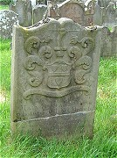 | 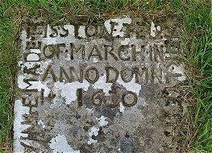 | 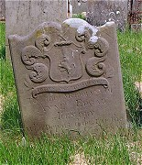
Mary Todd alias Wilson | Children of Walter Kid | Anne Edgar McKendry
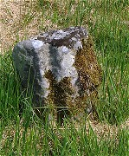 | 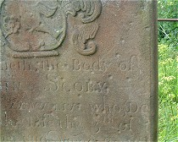 | 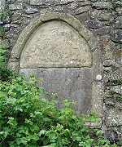
Spanish nobleman? | John Scoby | Florence McPhilip
The oldest legible gravestone dates to 1630 and is inscribed as follows:- 'HERE LYETH THE CHILDREN OF WALTER KID MARCHANT IN DUNLUCE BURGES OF IRVINE MADE THIS STONE THE 12TH MARCH IN ANNO DOMIN 1630' , there are many other interesting headstones displaying 'coats of arms'. A story surrounds one of a John Scoby whose headstone bears round markings produced when a shotgun was fired at grave robbers - whether they were trying to rob John Scoby's grave is not clear - it was normal practice to find people staying guard over newly buried relatives during times of high incidents of grave robbing, St.Cuthbert's had many wealthy merchants laid to rest within its walls and combine with tales of Spanish sailor may have made it a more attractive location for grave robbers. Another headstone mounted inside the church is inscribed :- ' HERE UNDER LYETH THE BODY OF FLORENCE McPHILIP, ALIAS HAMILTON, LATE WIFE OF ARCHIBALD McPHILIP OF DUNLUCE, MERCHNT, AND DAUGHTER Of CAPTAINE ROBERT HAMILTON OF CLADY, WHO DEPARTED THIS LIFE THE 20TH OF JULY 1974. 'DEATH CAN DISSOLVE, BUT NOT DESTROY, WHO SOWS IN TEARS SHALL REAP IN JOY''. The graveyard has many unmarked stones, some protrude through the thick grass cover like the tops of small standing stones. It is intriguing to think that some of these could mark the final resting place of members of the Spanish nobility. From medieval times, as the gravesite filled, burials would take place on top of other burials - which is why we find uneven surfaces at ancient burial sites.
Back

4:- Franklin Bradley,
Franklin Bradley
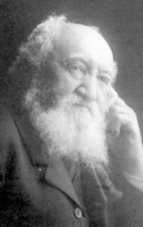
Franklin Bradley (2 February 1831-3 May 1909) was a Non-Subscribing Presbyterian minister in Northern Ireland and England and the first minister to Unitarians in Auckland, New Zealand. Subsequently he was a pioneer farmer, Justice of the Peace, and community leader in Arapohue, New Zealand.
Born at Carsonstown, Saintfield, County Down, Northern Ireland, Franklin was one of eleven children of Alexander and Susannah Bradley. His father, a Wesleyan, was a farmer and hotel keeper in Saintfield. His mother was Unitarian. Franklin studied until 1849 at the Collegiate Department of the Royal Belfast Academical Institution. Under the care of the Remonstrant Synod of Ulster, Presbytery of Bangor, 1850-55, Bradley was taught by two of his professors, Henry Montgomery, leader of the Synod and an Arian, and William Bruce. Having been given a license to preach, Bradley served the Bowden Hill Chapel, at Credition in Devon, 1855-59.
In 1859 the Presbytery of Bangor ordained Bradley to the pastoral charge of the congregation of Ravara, County Down, a position he held until 1862. He succeeded John Jellie, whose nephew, William Jellie, was to follow Bradley as the second minister at Auckland. He was active in the Remonstrant Synod of Ulster, attending a special meeting in 1860 where he joined with others in objecting to tests being put to entrants to the ministry.
While at Credition Bradley learned of another Unitarian, Thomas Alexander Kidd, formerly a Magistrate and Police Commissioner of Newry, who had gone to New Zealand in 1859. Subsequently the Kidd family sent back favorable reports about their new country. When Bradley returned to Ireland he discussed the possibility of emigrating with his family. Except for one brother who was a Royal Navy surgeon, they all decided to go to New Zealand. At this time the Auckland Provincial Council, offering land grants, attracted many non-conformists to the Albertland settlement, north of Auckland. After a rough voyage the Bradley family arrived in Auckland in 1863. The Bradleys decided to acquire better land north of Albertland at Arapohue. Because the land was as yet unsurveyed and war had broken out between the settler government and the Maori, they remained in Auckland and started a firewood business.
About this time a Unitarian Society had been formed in Auckland. In 1861 there were 161 Unitarians in New Zealand, half of whom were in Auckland; by 1864 the total had increased to 296. Although Bradley had been given books by the Belfast Unitarian Tract Society to assist in forming a congregation, he made it clear that his Auckland ministry would only last until he could take up farming. The first service took place in 1863 at the Odd Fellows' Hall. Bradley was ably assisted by the Chairman, Richard Ridings, and the Secretary, Fredric J. Utting. Members of the congregation edited and published Hymns for Christian Worship, 1863.
In the first few months the congregation increased steadily, collections covered expenses, and the committee expected to be able to raise 150 pounds per annum towards a minister's salary. In 1864 they resolved to build a chapel and to ask the British and Foreign Unitarian Association (BFUA) to send out a minister to relieve Bradley. They hoped that the BFUA might contribute to the building fund rather than make a grant in aid of a minister's stipend. Circulars were sent for distribution and the BFUA was asked to advertise in the Inquirer and Unitarian Herald seeking donations or subscriptions.
The BFUA, however, did not provide substantial help. They sent a supply of books and tracts, and their regrets. There were no applications from ministers for the pastoral charge at Auckland. The church saved on hall hire by meeting in an auction house owned by a member of the congregation. In 1865 the Bradley family finally moved to their land in Arapohue. The Unitarian congregation continued to meet under the leadership of Utting, a civil engineer and surveyor. When Utting moved to Albertland in 1866, the first Auckland Unitarian church faded out of existence.
While visiting Thomas Kidd in the Bay of Islands, Bradley fell in love with Georgina, one of Kidd's daughters. They eloped in 1865. Life at Arapohue was hard for the first few years, breaking in the land and building permanent houses. Bradley's own house, Enderly, was not completed until 1873. Franklin and Georgina had seven sons and two daughters.
In 1869 Bradley was appointed Justice of the Peace. Cases of cattle rustling, assault and murder appeared before the court. Between 1870 and 1872 he was a member of the local Road Board which made contracts with farmers to cut roads out of the bush. Following the abolition of Provincial Government, Bradley stood for Parliament in 1876 contesting the Marsden seat in the general election. He lost to Sir Robert Douglas. In the election in 1890, following Sir Robert's retirement, Bradley addressed a political meeting which carried resolutions in favor of the abolition of property tax, more land for settlement, and free secular and compulsory education. Because a number of his children had attended the Arapohue School in the 1880s Bradley took an interest in education and served a term as chairman of the school committee. As first president of the Northern Wairoa Agricultural and Pastoral Association, 1892-94, he is remembered as being a strong advocate of an annual show.
In 1900 William Jellie arrived in New Zealand to take pastoral charge of the Auckland Unitarian Church, which had been reestablished under lay leadership in 1898. He soon sought out his predecessor and fellow countryman. At the inaugural service of the Auckland church building in 1901, when Jellie preached to a congregation of about 250, one of the speakers was Bradley.
Bradley died at Enderly. A graveside service at the Arapohue Cemetery was conducted by F. W. Young, Anglican Vicar of Northern Wairoa. Georgina was buried next to Franklin in 1922. Afterwards an obelisk was erected to commemorate their lives.
For primary information on Bradley and the Auckland church see Northern Ireland Presbyterian Historical Society Archives; Minutes of the Remonstrant Synod of Ulster, 1860; The Inquirer (1 November 1862 and 28 January, 1865); annual reports of the British and Foreign Unitarian Association, 1864-65; Samuel Bradley, "The Diaries of Samuel Bradley November 1868-December 1874" (unpublished manuscript); and Auckland Unitarian Church Calendar (May 1901 and June 1909). On the Bradleys see "The Story Of The Bradley Family Which Settled In Arapohue In 1865," New Zealand Biographies (1952) and K. F. Bradley, The Bradley Family Tree 1863-2003 (n.d.). On the Auckland Unitarian church see "Early Days of Auckland Unitarianism", Auckland Unitarian Church News and Views (April 1968) and J. Maindonald, A Radical Religious Heritage (1993). See also R. D. Woodall, "Bowden Hill Chapel, Credition", Transactions of the Unitarian Historical Society (1964); J. Stallworthy Early Northern Wairoa (1916); C. L. Shepherd, "The Albertland Christian Colonisation Movement" (MA Thesis, Auckland University College, 1942); and L. J. Owen, 126 Years in New Zealand: The Utting Story, 1860-1986 (1986). There is an obituary in New Zealand Free Lance (8 May 1909).
Article by Wayne Facer

5 . Shalimar Passenger List.

SHIPPING INTELLIGENCE. PORT OF AUCKLAND.
Daily Southern Cross, Volume XVI, Issue 1281, 23 December 1859, Page 2
About this newspaper
Back to issue contents
Article view

SHIPPING INTELLIGENCE. PORT OF AUCKLAND.
ENTERED INWARDS. December 20— Effort, 32 tons, Frost, from the Thames, in ballast, 5 passengers. December 20 — ]£iwi, 40 tons, A, McGregor, from Mongonui; in ballast, 12 passengers. — Cruickshank Smart and Co., agents. December 22— Laura, 16 tons, Hohua, from Waiheki, with 2 horses, 20 fowls, 3 tons potatoes, 1 ditto onions. — December 22 — Brothers, 22 tons, Johnston, from Waiheki, with 25 tons firewood. December 22 — Raven, 24 tons, Cacutt,fromMatakana, with 20 tons firewood and 9 pigs. December 22 — Annie Laurie, 35 tons, Norris, from Russell, with 3 tons oil, 14 do. v gum, 1 keg raisins, 2 boxes soap. Passengers — Mr. and Mrs. H. Clarke, Mr. Gibbs, Mr Smith. December 22 — Aquila, 27 tons, Austen, from Russell, with 37 empty barrels, 2 do. bags. December 22 — Ann, 20 tons, McMillan, from Waiheki, with 35 tons firewood. December 22 — Shalimar, 1402 tons, Brown, from Liverpool. Passengers — Cabin : Mr. Melling, Mr. Masefield, Mr., Mrs., William & John Bonar ; Miss Paton, Mr. Allott, Mr. & Mrs. Huston, Albert Guly. Steerage — Geo., Mary, Eliza, Mabel, George, Agnes, Augusta, Ada; Eva Wyatt ; Ellen Eames, J. Garden ; Wm. Murray, Sam. Johnston, Hugh, James Wylie ; Walter Humes, Teresa Swift, Geo. Craig, James, Mary, and Mary Lamb ; Edwd. Leyland, Thos., Mrs., Maryanne, William, Thos., Deborah, Harriet, Lavina, Agnes, Francis, Isabella White ; Ptk. Darcey, Thos. Bostock, Gr. Roberts, John Beadew, Dan. Pettigrew, Pat. O'Callaghan, John Cockrof t, Wm., Helena, Ann Flavell ; Septs. Mason, J., Sarah Edmondson ; John Freeman, T. Ferris, Christopher, Isaac Smith; W. Thomson, Richard, Maiy A., Bridget Daly ; John Duddridge, John Miller, John Fulton, Dan. Delany, Mr. Jones, Mr. Davis, William, Mary,. Mary, Janet, William, JohnV. Kerr ; John, Mrs., Charles, Miriam, Thomas, James McDonald ; Chas., John Thomson ; Landey Batching, JohnForster, Johnßiley, William, Mrs., Harriet, William, Florence, Ernest, Meteor, Bridget McKinistry ; Thos. Waring, Edward, Margaret, Anne, Susan, John, Henry, Edward, James, Eliza, Hy. Pilkington ; David Fisher, Saml. Young, Anne Fisher, Thos, Singlehurst, Jas. Brandon, James Faughey, George, Susan Langlands ; Hannah Backhouse, Thos. A., Mrs., Eliza, Georgina, Mary, Helen, Fanny, James Kidd; DavidCarden, Alex. Woodbury, George, Sarah, Sarah Cumming ; W. Sterling, John, Mrs. Beadon ; Wm. McCullum, Geo. Hunt, John, Mrs, Swales and 2 children ; Wm. 8., Eliza Evans ; Chas., Eliza, Cleveland ; Anne Bagshaw, James, Mary Durand ; J., Susan, Peter, J. Bridget Drongool ; James, Charles, Michael, Patrick, and Mary Anne Drongool ; Mary Hanlon, Thos. Hirst, George and Wm. Smith, John Watson, Jas. Curtain, Patrick Kerrish, Arthur Cleaver; William, Anne, George, Arthur, Jane, and Win. Appelyard; Geo. Cooper, Josh. W. Horton, Mrs. Horton and infant, John and Mrs. McLeod and family (3), Chas. H. Jones ; James, Mrs., and Thos. Walker ; Mary and Henry Thomson, Alex, and Hugh McLean, Jos. & Sophia Muvin, Wm, Brown, Rob. Essam, Anna McCormick, Jas. McKeown, Win. Hawls, George Bradbury ; Amelia, George, and Wm. Clad worthy; Henry and George Kent, Edward Morton, Ralph Smith, John Kemp, Joshua Rushworth, John and John Miles, Jas. Crossley, R. Goodworth, Geo. Rymer; Jos. Isabella, James, Isabella, Joshua, and Robt. Dixon ; Mathew Howat, John Ouaeley, Joseph Cliff, Andr*w Hunter, Jas. Banks, Daniel Cuddy, Jas. Edmondson, John Longworth, John Moffatt ; Susari, Jane, and Susan Dalghish. — O. R. Strickland and Co., agents.
CLEANED OUTWARDS. December 20 — Ant, 20 tons, Henare, for Tauranga, in ballast, 1 passenger. December 20— St. Kilda, 83 tons, Tautwri, for Russell, with 2 coils rope, 1 cwt. soap, 4 cwt. sugar, 30 pckgs. sundries. Passengeis — Bishop of Waipu, Mr, T, C. Williams, Mr. and Mrs. Whiting, and 2 children, Miss Gardener. — S. J. Edmonds, agent. December 20 — Lily, 17 tons, Eggerton, for Waiheki, in ballast. December 20— Victoria, 18 tons, Poulgrain, for Waiheki, in ballast. December 20 — Mystery, 10 tons, Trimmer, for Waiheki, with 10 cwt. flour, 5 bags sugar, 40 lbs. tobacco, 20 pigs, 1 passenger. December 20 — Wairoa, 15 tons, Turner, for Wairoa, with 2 tons flour. 10 cwt. sugar, 8 gallons rum, 2 cases ale, 1 plough, 6 bags bran, 6 bags maize, 5 packages furniture. December 20— Marawini, 16 tons, Hoani, for Mangawai, in ballast. December 20 — Effort, 32 tons, Frost, for Oma and Ahuriri in ballast. December 22— Brothers, 22 tons, Johnston, for Wai« held, in ballast. December 22 — Laura, 16 tons, Hohua, for Waiheki, in ballast. December 22 — Kiwi, McGregor, for Mongonui, with 2000 feet timber, 2000 shingles, 1 ton flour, 30 pkgs. sundries, 1 case transhipped ex Nourmahal, 1 case, 2 horses, and 6 male passengers. December 22— Satellite, 30 tons, G. H. Cleveland, for Napier, with 800 feet house blocks, 200 posts, 35 tons firewood, and 4 passengers, i December 22— Ann, 20 tons, McMillan, for Waiheki, [ in ballast.
! IMPORTS — FOREIGN. Per Shalimar from Liverpool — 87 camp ovens,j4 casks paint, 8 casks oil, 14 bundles forks, 4 casks 1 case hardware, 5 trunks merchandise, order; 1 case merchandise, Samuel Rout; 4 cases do., Geo. Samuel Graham; '5 bales paper, Gilfillan& Co. ; 23 chests tea, 10 barrels pork, 5 boxes provisions, order; 60 cases bottled beer, Cruickshank, Smart & Co. ; 5 pkgs. merchandize, Brown, Hall & Co. ; 35 packages merchandise, 1 boiler, 1 furnace, (2 cases) 1 fly wheel, 1 bundle gas tubing, 860 fire bricks, 5 tons pig iron, Newman and Ewen ; 2 cases merchandise, Henry Isaacs; 7 pkgs. merchandise, E. H. Isaacs ; 3 ooxes, 2 bales, Archibald Clark ; 1 box, G. S. Chapman ; 250 casks bottled beer, Gilfillan & Co. ; 11 pkgs. merchandise, 100 bags, 12 mats salt, Ritchie & Smythyman; 1 case merchandise, J. H. Burnside fc Co. ; 12 packages merchandise, 3 raokages do., Gilfillan & Co. ; 1 box jewellery, Newman k Eweh; 115 cases porter, 238 cases ale, 500 bags common salt, 506 bags stored salt, 24 tons coke, 42,000 slates, 170 boxes soap, 11,320 building bricks, 1,000 blue fire bricks, 419 flag stones, 500 bags Indian com, 5i spruce deals, O. It, Strickland & Co. ; 28 packages
merchandise, 20 kegs nails, Saml. Fleming; 1 box merchandise, Thos. Hirst ; 1 box merchandise, E. J. Cudd; 59 pkgs. merchandise, 9 bags nails, Thos. A. Kidd. For Wellington— so cases beer, Smith & Co. ; 3 bids., 2 hhda brandy, 1 box samples, order j 5 bales paper, W. &G. Tumbull ; 2 casks, 1 case merchandise, J. Y. Aston ; 250 casks beer, Smith & Co. ; 4 cases merchandise, T. C. Smith; 1 box merchandise, John Leal ; 200 boxes, 300 boxes soap, order.
A ship was signalled in the evening of Wednesday, but her number was not made till the* afternoon of yesterday, when she proved to be the White Star clipper Shalimar. She brought up »t about 6 o'clock inside the heads, wind and tide being contrary. The Shalhnar left Liverpool, on the 12th Sept. at 630, and cast t>ff her tow on the following day with a fine fresh breeze at>N.E. Palma was sighted on the 30th Sept., and San Antonio on the 7th Oct. She passed to the westward of Cape de Verde ; picked up a fresh N.E. trade in 11 o N.,'and carried it to the line, which was crossed on the 19th Oct. Immediately after passing the Equator the S.E. trades were fallen in with and remained steady down to the 38th paralell. Trinidada was sighted on the 25th Oct. bearing W., and the Meridian of the Cape was passed on the 14th Nov., in latitude 42 » . The Shalimar ran down her easting in about 43 o , beautiful weather prevailing the whole time. During this part of the voyage five icebergs were seen. Cape Ofcway was ma^e on the Bth Dec, and Bass's Straits passed through on the 10th. On Saturday last the Shalimar rounded the Three Kings, and she has since experienced light winds. Captain Brown reports the crew and passengers healthy. 3 children died on the voyage, and a marriage took place. The Shalimar seems a comfortable vessel, with exceedingly good accommodation for passengers.
