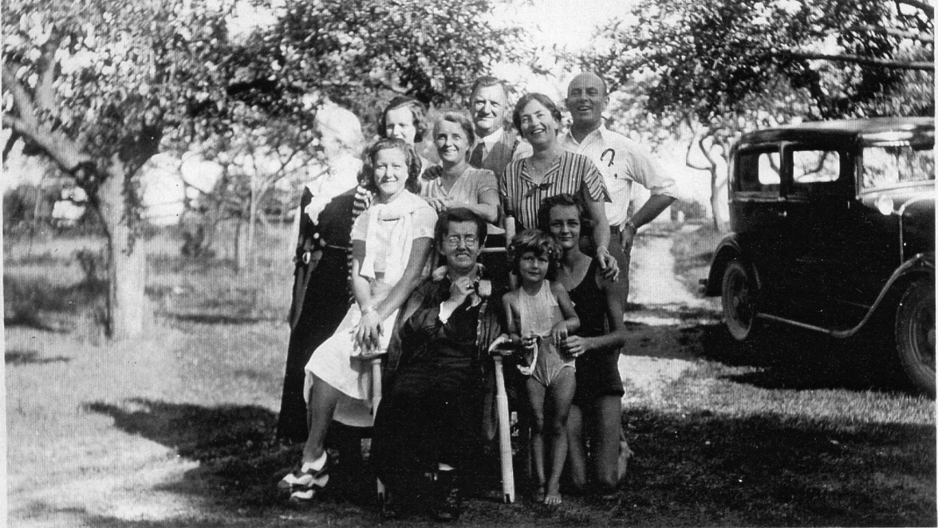
L Back row: Matilde Beaudry Kidd, Eleanor Kidd, Hazel Irene Dixon Kidd, George Claude Kidd, Molly Clarke Kidd, John Norman Kidd?
Front Row: Hazel Kidd, Marguerite Kidd (in wheel chair) Madge Kidd, Mary Alice Kidd

Early 1930s at the cottage on Bay of Quinte

