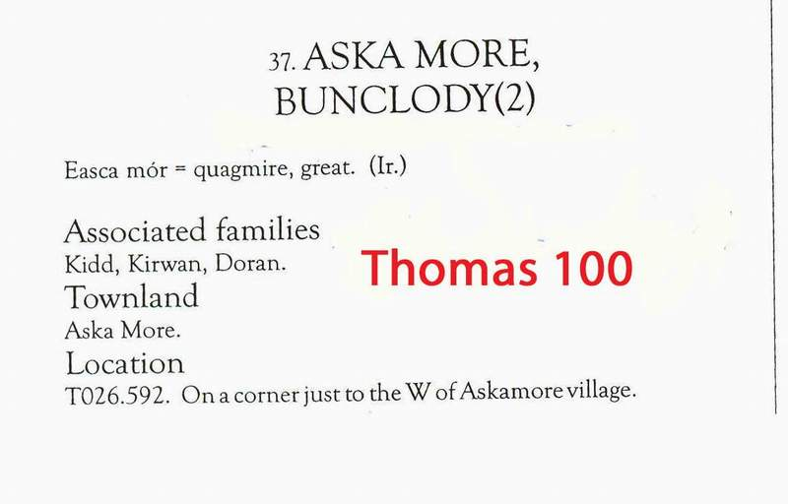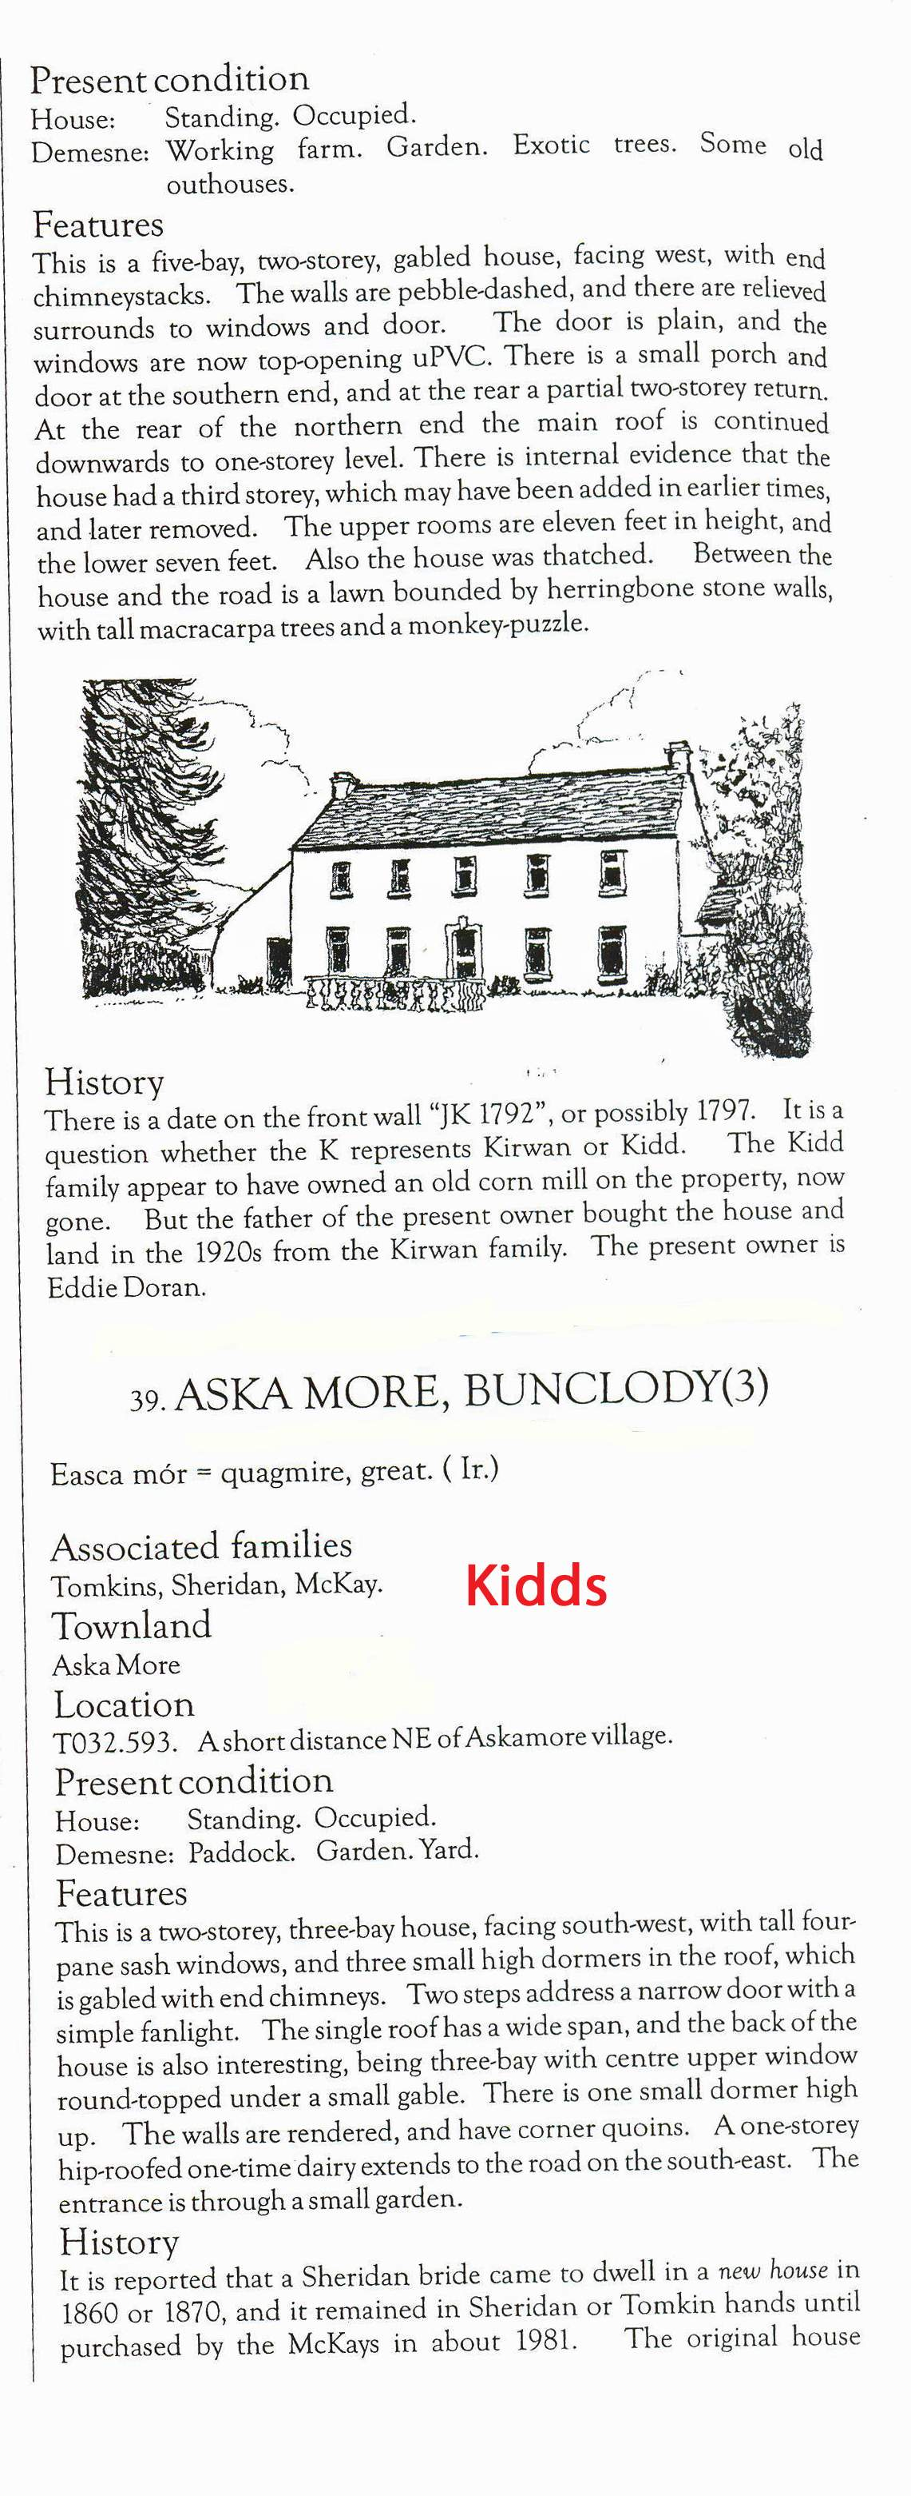

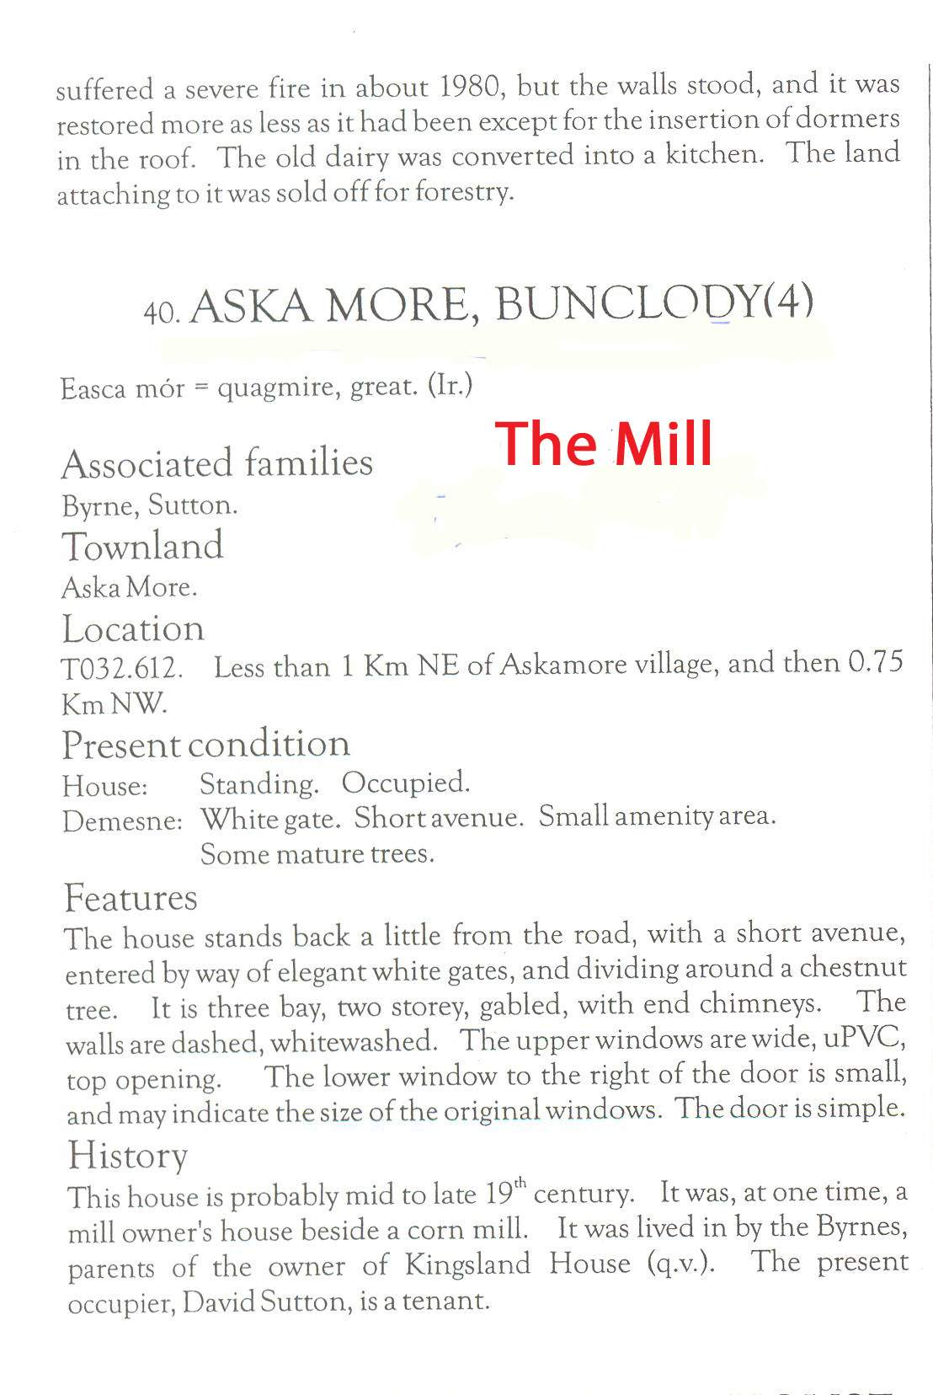
Local folklore has it that the house and farm known as the mill was the homeplace and their they had three sons, the farm at that time is said to have about 800 acres which in irish terms would be very big considering most people would have been living on about 10/20 acres it is believed the farm was at some stage split into three parts one being the mill,another being where Thomas 100th lived and the other being where people by the name Mckays live, Also if you look up the Failte Ireland website and go for loop walks look for Askamore,Sliveboyor Ballybeg loop walks where these walks are now set up would have been a lot of the Kidd lands not all but most of them,there is on part of the walk a place called Kidds gate,it also apears that the house where Thomas 100th lived was a three story house again which would been rare here at that time

