BALLYRANKIN – Daphne Cottage
&
The Kidd / Pierce Families

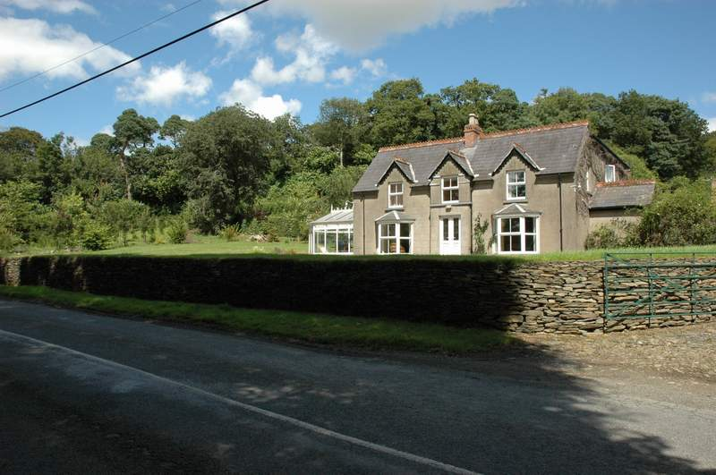
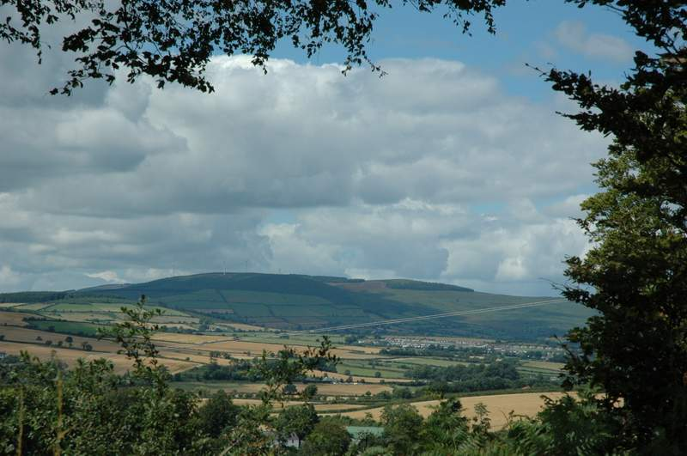
Ballyrankin Countryside

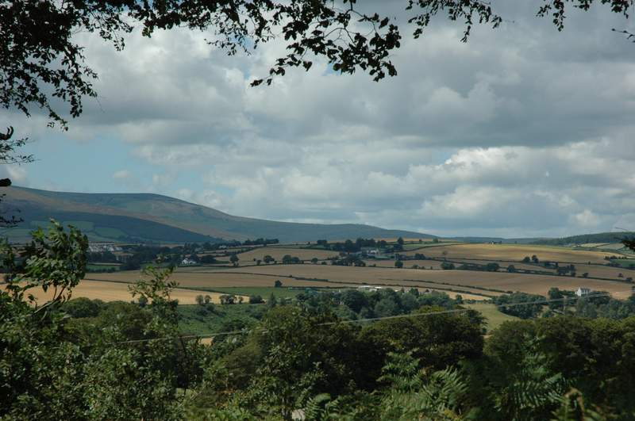
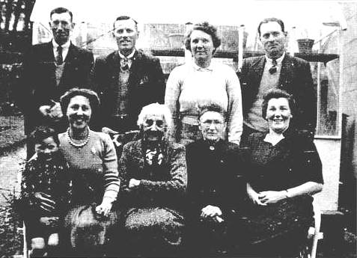
William Pierce, William Kidd, Caroline (Carrie) Kidd (nee Fenton), Jack Kidd
Victor Kidd, Annie Downs (nee Pierce), Mary Pierce (nee Butler), Elizabeth (Bessie) Kidd (nee Wellwood), Eleanor Kidd (nee Pierce). C 1930’s
Carrie and Jack with their son Victor, William and Eleanor are married, Mary Ann is the mother of the Pierces... William, Anne and Eleanor. Elizabeth is the mother of Jack and William Kidd
Elizabeth was married to Thomas Kidd 1852-1919 (John6, Joseph5, George4th generation)

