Ballyrankin and Kilrush Sites
St. Brigid’s Church, Kilrush
Kilrush Crossroads

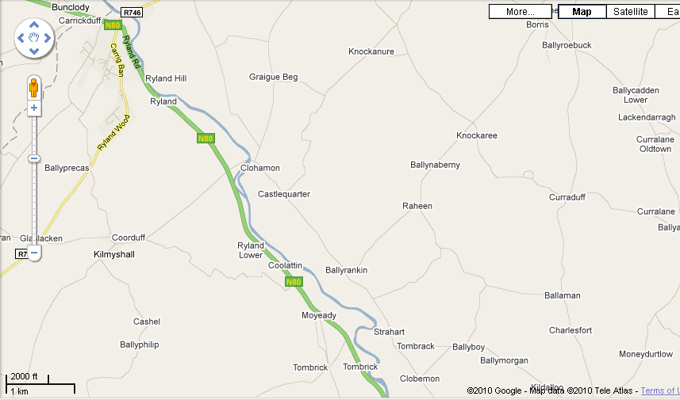
Daphne Cottage
Ballyrankin Farm
Sheila’s House
Raheen

St Brigid’s Church
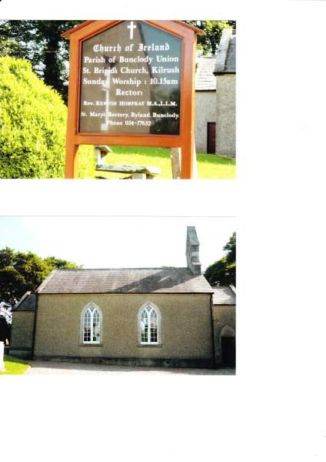
School at St Brigid’s
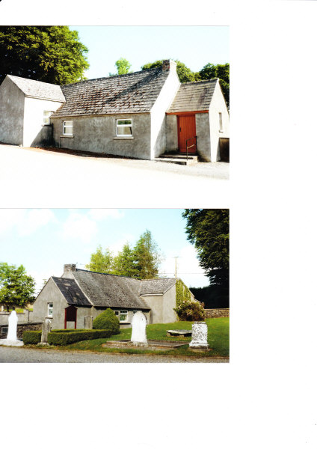

St Brigid’s Church
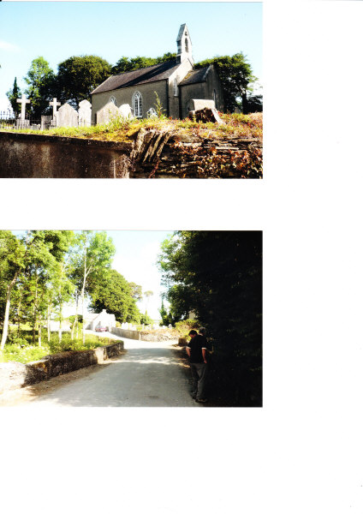
Kidd Pew in St Brigid’s
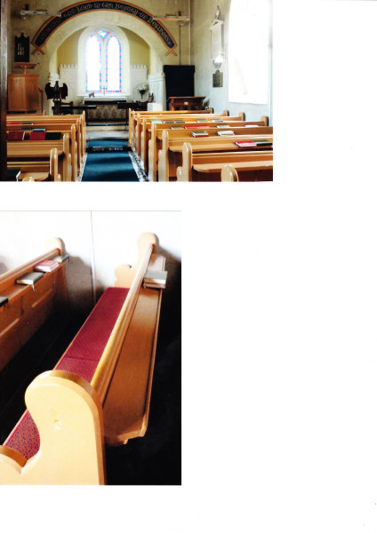

Top Grave of Elizabeth (nee Wellwood),Wife of Thomas
Next John and Carrie Kidd (see Appendix 2)
Bottom Mary Anne Daughter of Elizabeth

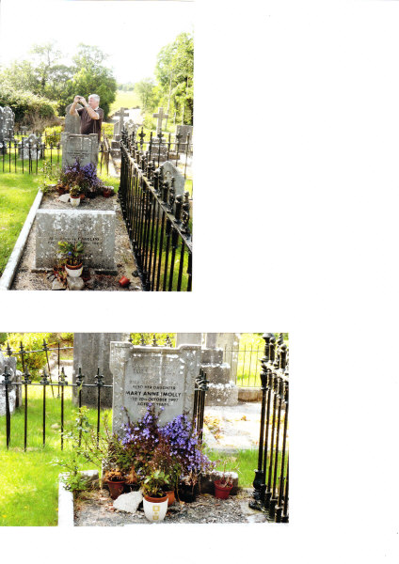

Small Stone Thomas Kidd 1852 - 1919
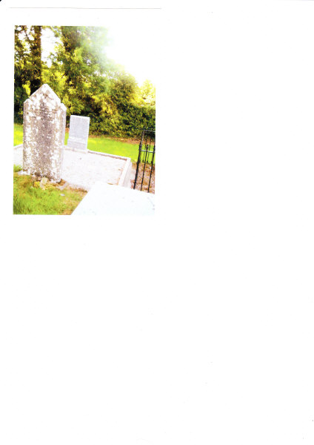

1800’s Kidd Home in Raheen
