By Jane Kidd Reid Minden – A very brief summary of the Richard Kidd family

Richard Kidd was the son of John Kidd and Margaret Garland. He was born on June 26, 1835 in Beckwith, probably on the original Kidd farm in Franktown. The 1852 Census for Canada West, Beckwith Township, Lanark County shows Richard living with his widowed mother, Margaret, and all of his brothers and sisters except for Thomas, who had moved out of the house. However, Edward, my great grandfather is not listed. He would have been 3 years old.

The following inset, originally written by William Livingstone Kidd, was compiled and transcribed by Fred Kidd (now deceased) of Cochrane, near Calgary, Alberta, Fred was the grandson of Richard’s brother James Kidd. Another brother of Richard Kidd, Joseph Kidd, had a son, William Livingstone Kidd who wrote his memories of the Kidd family. (Joseph and his son William Livingstone stayed on the original Kidd farm in Franktown, near Carleton Place, Ontario). The article was provided by Dorothy Kidd Lewis, daughter of Livingstone Kidd.

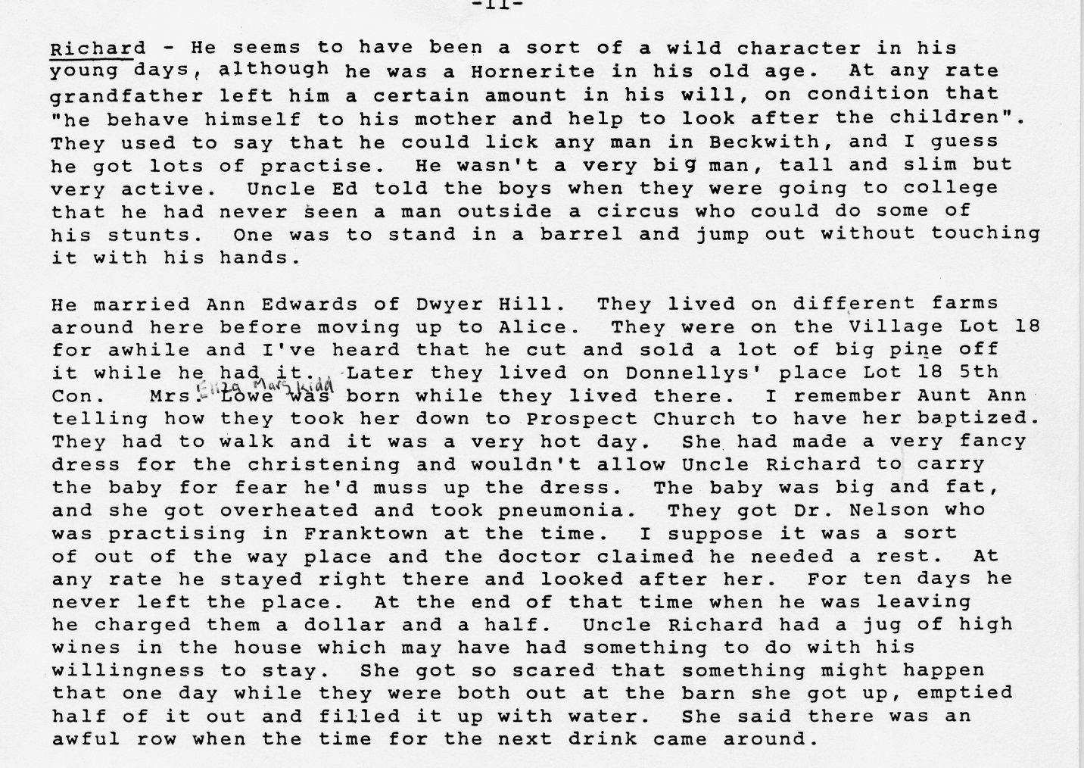

Vi Kidd Brooks, Richard Kidd’s great granddaughter, recalled many family stories – some about her great grandfather and her grandfather, George Wesley Kidd. They were both quite violent men; even harming farm animals. The details will not be repeated. Fortunately for Vi and her family, her father, Manson Vernon Kidd, was a very kind, gentle person. Although Vi did not know her great grandfather, Richard, she had heard many stories about him. Her grandfather, George Wesley Kidd didn’t die until 1951, so she knew him well.

In 1851, Richard’s future second wife, Annie Edwards, is living at Con 6, Lot 21P, Beckwith Twp., Lanark, Ontario.

According to other research, Richard first married Elizabeth Hodgins about 1855. They had one son, George in 1856, before Elizabeth died in 1857. There is no record of George living with Richard’s family.

Ontario Marriages for 1800 to 1910 shows Richard, at age 24, marrying Annie Edwards, daughter of George Edwards and Janet Moore of Dwyer Hill, on March 22, 1859 in Lanark, Ontario.

According to Methodist Baptism Records, their first child, John, was born eight months after their marriage on November 29, 1859.

The 1861 census shows Richard and Annie living on Con. 5, lot 19, Beckwith Twp. Lanark Co., Ontario. According to Livingstone Kidd, they moved to several farms before settling in Alice.

Between the 1861 and 1871 census, they had a daughter, Annie E., who was born in May of 1867 and died at age three months.

By 1871 Richard and his family are living in North Renfrew, Alice and Fraser District. Richard is 35 and Annie is 32. Their children are listed as: John 11, Margaret 10, Jenny 8, George Wesley 6, James 3 (deaf), and Annie 1. It appears as if Richard and Annie had another girl around 1870 and named her Annie, as their first Annie had died.

Between the 1871 and the 1881 Census, young Richard died at age 6 on August 1, 1877.

According to Livingstone Kidd, the farm in Alice was not very productive, so they moved to the Locksley area. In the 1881 Census for Wilberforce, Renfrew North, Richard and Annie are living with John 21, Jenny (Janet) 18, George Wesley 16, (James) William 14, Anne 12, Joseph 7, Edward 3, and Thomas Eli 1.

Between the 1881 Census and the 1891 Census, two more of their children had died. On December 25, 1888, Jenny died at age 25. On Nov 11, 1890, William died at age 24.

The 1891 Census for Wilberforce, Renfrew North, shows Richard and Annie living with their children, Joseph 19, Edward 11, and Thomas (Eli) 10. The ages of the children do not seem to be consistent, but are close.

On December 2, 1900, Thomas Eli, died in what appeared to be an industrial accident. He was living and working in Sault St. Marie Michigan. The Michigan death records listed the Chippewa Company. Eli was only 20 years old and single.

Richard and Annie had 11 children- five who died either as children or young adults. All of these children are buried in Rankin Cemetery, Wilberforce, next to their father’s grave stone.

Both Richard and Annie were still alive in 1901, but they are not listed on any of the Census Records. Richard died on August 20, 1903 in Beckwith. Richard’s wife, Annie, evidently died in 1916, but where she is buried seems to be somewhat of a mystery.

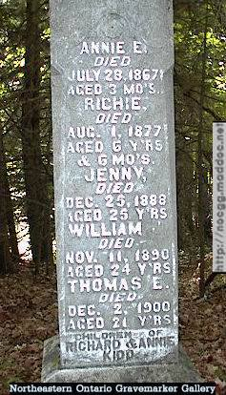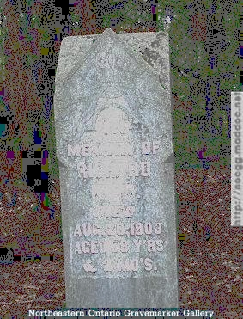

1) John Kidd (1859-1927) was the oldest son of Richard and Annie. He married Margaret Jane Lowe and had four children. Most of their family stayed in the Renfrew- Ottawa area.

2) (Eliza) Margaret (1861-1940) married Henry Lowe and had five children. Most of their family stayed in the Renfrew area as well.

3) Janet (Jenny) (1863-Dec. 25 1888)

4) George Wesley Kidd (1864-1951) moved to the Restoule area in 1885 and married Isabella Hamilton where they remained.

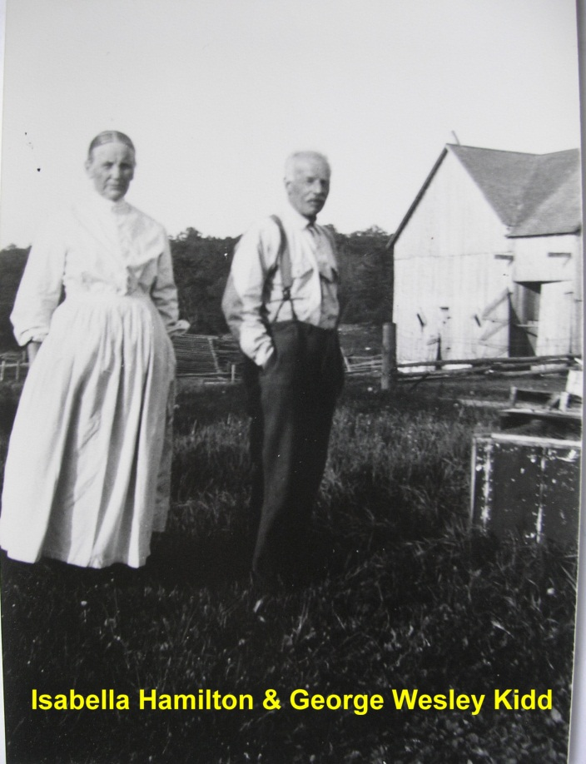

In an article (about 100 years ago in 1988) in the Highland Herald (June 21, 1988), Kidd’s Corner and the George Wesley family were highlighted. They had five children. A couple of their sons stayed in the Restoule area, opening a General Store. They eventually moved to the Sundridge area where their grandchildren run Kidd’s Home Hardware (2013).

It appears as if Richard Kidd’s athletic ability has continued down through the generations, as his grandchildren, great grandchildren and great great grandchildren, including some females have played hockey, (Josh Kidd was drafted to the NHL but in 2013 is playing defense for the University of New Brunswick. Josh’s sister, plays for the University of Western. A few are runners. One female, Annie Lennox, loves horses and is a famous author. She has written a book about “Northern Dancer” as well as many children’s books. (She lives in the Toronto area). All of these Kidds seem to be very intelligent, winning all sorts of academic awards.

Richard’s grandson, Manson Vernon was a very kind, gentle man, unlike his father and grandfather. Many of his family members stayed in the Restoule, Loring, and Powassan area. Manson’s daughter, Violet Kidd (1925-2009) had provided many dates as well as stories about the Kidds in the Restoule area. Her family is spread out from Powassan, to near Timmins, to western Canada.

5) William James (1866-Nov 11 1890)

6) Annie E. (May 1867- July 28 1867)

7) Annie (1870-

8) Richard (1871- Aug 1 1877)

9) Joseph (1873-1953) married Pearl Brownell. Joseph’s family has many family members in the Pembroke- Ottawa area.

10) Edward Kidd (1877- July 20 1878) married Florence Clark. One of their children, Dorothy Kidd, although born in Saskatchewan (1915-2008), married Steven Childerhose (1907-1990). Their family has remained mainly in the Pembroke- Ottawa area. The Childerhoses have done extensive work on their line of the family.

11) Thomas Eli (Dec 19 1879-Dec 21900)

